Date: 11/14/16

Members Present: Noah, Russell, Caileen

Goals: Work on Launcher

What was Done:

* While the launcher was entirely built at the beginning of this meeting, we realized it needed a bit of fine-tuning, and so we made a few adjustments to the overall gearing system of our robot:
  + The lift was offset – due to the way the gear was positioned, it would launch before it reached its lowest point, which it needs to do in order so that we may pick up stars. Therefore, we had to readjust the gear, and make the overall system lower, so that the intake could actually pickup game objects.
  + We were also unhappy with the amount of time it took for the overall system to go down, and realized we had more teeth on our gear than we needed, and so we decided to chip off teeth, and adjust the launcher accordingly.
    - We chipped off one tooth at a time, testing in between each iteration, and found we liked the system after we had chipped off two teeth – making 14 chipped off in total, making the 36-tooth High Strength Gear a 22-tooth slip-gear.
  + Since we believed the amount of time it took to launch could be improved even more, we decided to test out how we could improve the overall lift system by changing the amount of total rubber bands on the lift system. After taking one rubber band on each side off per test, for a few tests, we settled on using 9 #64 sized rubber bands.
  + After we had finished testing these aspects of the launching system, we decided to get benchmarks for our launcher, so we would know how such a system would perform – if we redesign, and our future robot is worse than the benchmarks set by this robot, we will want to rebuild this robot.
    - We found this robot could launch one star from the outer edge of the far zone to the other far end of the far zone.
    - This robot could launch two stars, as well as a cube, from the inner edge of the far zone to the outer edge of the other far zone.
      * These benchmarks were taken with a low charged battery, as we wanted to test for worst case scenario, as there will be time in tournaments where we forget to change batteries before some of our matches.

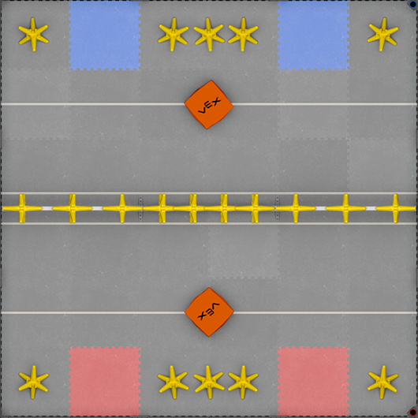

**Lift Overview**

* Lastly, we made a secondary slip gear, as we want to have a second one in the off-chance that the gear will break in the middle of competition.

Goals For Next Time: Test launcher more; make beneficial changes to the launcher

Date: 11/17

Who Was There: Spencer, Noah, Max, Kyle, Caileen

Goals: Make Lift/Intake More Efficient

What was Done:

* We realized as a team that the ability of our intake was holding back the amount of game objects we were able to score in any given time. We discussed possible ways of improving and/or overhauling our current intake design. We came up with three possible options:
  + We could make the overall intake wider.
  + We could add a set of pneumatic claws to the side of the robot, compressing the stars into a smaller space, like shown below.
  + We could add a hopper-like system to be able to hold more stars in an upwards direction, like shown below:

**Pneumatic Claw**

**Hopper**

* Choice of Design / Explanation: We chose to start building a pneumatic claw. While this is subject to change, a pneumatic claw seems like the most efficient way to get more stars on the same amount of space. Furthermore, while expanding the claw would make it more efficient, at this moment, we are unable to expand it, as it will interfere with our drive wheels.
  + Since these claws will be stationary, they will not cause our launching time to be slower, as there will not be more weight at the bottom of the fulcrum, as the other two solutions would do.
  + The main problem with this design is the fact that pneumatics only allows a very limited range of motion, so it will be a challenge to get it to both function as a claw and stay within 18 inches at the beginning of a match.
    - We may possibly be able to use motors instead of pneumatics for this purpose, but we believe pneumatics will give us a more consistent claw overall.
* We then built this claw archetype by attaching pneumatics to the base of our robot, which in turn was attached to two wide C-Channel, that would function as claws.
  + Due to the issue of space, we realized we would not be able to implement this design before the upcoming tournament, and instead decided to keep the overall built claws, to be implemented for future tournaments.
* After the claw was assembled and taken off the robot, we dedicated the rest of the time to practice driving. With coaches by them, Noah and Spencer took turns practicing driving, so they could get acquainted with the overall controls of the robot. However, before the meeting was over, the launching system became out of sync, and we will need to fix that at our next meeting.

Goals for Next Time: Fix Launcher

Date: 11/18/16

Members Present: Noah, Spencer, Max, Kyle, William

Goals: Driver Practice, Testing Lift

What was Done:

* We started today by fixing the lift, as at the last meet, it had been offset. Fixing this was a simple matter, and solely involved shifting the positioning of the slip gear a small amount.
* After this, we decided to allow our drivers – Noah and Spencer – and their prospective coaches – Max, Kyle, and Russell – and had them drive around the robot in order to show them the many possible situations that could occur while the robot is driving.
  + We made a few realizations that we will implement into our overall strategy in regards to the overall robot:
    - We will need to keep the intake system above the ground at all times, except when we are able to intake game objects into our robot.
      * We will look into the possibility of adding code to our overall driver program to do this automatically, so the driver need not worry about it.
        + Furthermore, keeping the intake off the ground while we are moving, when done through the code, will minimize the amount of friction between the robot and the ground, allowing us to travel faster.
    - We realized offsetting the overall lift system was extremely easy to do, and overtime, through incremental error, the launch angle will shift. As of now, we cannot determine a possible way to fix this error, so we will have to keep an eye on it, as any shift in the launch angle will change the trajectory of the game objects for the worse.
  + The practice ended with the lift getting offset again, and thus, we will have to fix it at the beginning of our next meeting.

Goals For Next Time: Realign Slip Gear

Date: 11/19/17

Who Was There: William, Noah, Russell, Caileen, Spencer

Goals: Fix Launcher

What Was Done:

* We found the reason the lift angle was becoming more and more offset over time. When the lift motors were run into the ground for longer than necessary, the gear system would skip, and the launch angle would be shifted.
  + William realized we could use the code in order to alleviate this problem. There were several potential solutions:
    - Using a single-wire encoder in order to determine where the lift is, and not having it go lower than the spot at which the gear would skip.
    - Using a potentiometer in order to determine where the lift is, and not allowing it to go further down than where the gear would skip.
    - Using a limit switch in order to stop the lift when it would get to low.
  + Choice/Explanation: We decided to go with the second solution, for a very simple reason – potentiometers have 4096 different possible data points over 270 degrees, while an encoder only has 270 different data points, making the potentiometer more accurate. Furthermore, with a potentiometer, we would be able to also integrate some type of position control loop into the system, where with a limit switch we would not.

Intaking Position

Launching Position

Holding Position

Lift System

**Plan for the Lift Control Loop Code**

The intaking position would be used minimally; only when we needed to pick up stars, as otherwise, it will cause extra friction with the ground.

The Holding Position will be used while we are traversing from object to object, or getting ready to launch.

The launch position isn’t really a position, but launches the slip gear upon the push of a button, and goes back to the intaking position.

* + After deciding this, William decided to make a control loop while everybody else focused on driving practice.
    - William made a simple P loop as a proof of concept – if we decide to invest more time in this, we will create a PID loop instead. As of right now, it has not been tested, so we have placeholders for the important variable. Through this position control loop, we will be able to use buttons to put the lift in these separate positions – See Above.

Goals For Next Time: Test/Implement P Loop into Lift

Date: 11/23/16

Members Present: Max, Kyle

Goals: Fix Intake Angle

What Was Done:

* Since the intake and the lift meet at about a 45-degree angle, it is very easy for the angle of the intake against the ground to shift, and therefore not be able to pick up stars efficiently. We realized there were two main solutions that could fix this issue:
  + Extending the lift system via a piece of C-Channel upwards, so instead of changing the lift every time, we can adjust the C-Channel.
  + Creating a new intake system.
* Chosen/Explanation: Since having the C-Channel will allow the angle at which the intake and lift connect be at 90 degrees, instead of 45, the lift pushing down on the ground will create a system that actively makes our intake of choice flush with the ground, and therefore, allow us to pick up stars more efficiently.

**Lift Before**

**Lift Now**

* Lastly today, we decided to add a gyro sensor to our robot, as a gyro sensor will allow us to determine the angle which we are facing at all times. This will help us during the autonomous period of the game, and will allow us to turn during that period much more effective. While using the encoders could do this, and we will probably still use them to check the integrity of the gyro value, a gyro sensor will be able to calculate our heading with more accuracy than using the difference in the two encoder values.

Goals For Next Time: Adjust Launcher Angle due to the shifting of it, due to the extension of the lift system done today.

Date: 11/29/16

Members Present: Noah, Max, Spencer, Will

Goals: Adjust Launch Angle

What Was Done:

* The first thing we did today was attempt to implement the P Loop William made. After tuning the kP variable to about 0.4, and then found the ideal spots on the potentiometer for the intaking position and holding position.
* This was implemented successfully, however we found afterwards the launch angle was off. While this might have been due to the code, we determined it was most likely a hardware issue, and determined moving the slip gear upwards in order to make the launcher more effective.
* When we were taking apart the launching system, we realized it would be beneficial to have the ability to switch between a launcher and a lift. Unluckily for us, we realized we wouldn’t be able to create a system in which we could shift gears over in order to switch between these two systems, without having the gears hit the motors. We realized at this point, we had the option to decide in the moment if we wanted to go back to a lift, or stay as a launcher.
  + We decided to go with a lift system. While we have had negative views towards a launcher system before, through seeing many other lift designs on the VexForum, we realized it was probably a result of the way we built it.
    - The robots that used a lift system were not great because they could toss stars over the fence quickly, but instead because of their capacity. The design that showed us we should give a lift system a second chance was able to hold 5 individual stars. For this upcoming tournament, we hope to be able to hold 2-3.
    - We decided to stay with a 1:5 gear ratio lift system for torque in order to be able to lift a large amount of weight, while still having a quick lift time.

**Lift Gearbox on its Side**

* Because of the fact we decided to switch the lift system we were using, we realized our current intake system was possibly not as effective as it was before. There were two options we found concerning our intake system:
  + Make a claw system to horde stars in a single area
  + Keep our current forklift intake
* Choice/Explanation: We decided to go with the first option, as we mainly used the forklift in order to minimize the weight of the launch, while that is less of an issue with a lift system. Furthermore, since a claw will be able to group stars together, we will be able to carry more stars over the fence. Furthermore, due to the structure of the stars, if we place the claw in such a position that it grasps the star by the middle, it will allow us to carry a large amount of stars.
  + We built this claw system, using 22 long 3 wide C-Channel, connected to 8 long 3 wide C-Channel at a 45-degree angle, in order to have the claw be able to hold the stars up, rather than compress them, in order to hold them, thus eliminating much of the possibility of our motors burning out.
  + This claw system was built using a 1:5 torque gear (12 tooth gear to 60 tooth gear) configuration so we could quickly grasp stars, and also be able to apply a speed to hold them in the claw without our motors burning out.

**Claw Gear Box**

* We decided to put the free spinning motor encoders back onto the front of the robot. Since these wheels are not connected to a motor, they will only detect movement when the robot is moving, and not if the robot is not moving, but a motor is. In the future, we will need to create a system to push these wheels further into the ground, in order to eliminate the error of encoder slip.

Goals for Next Time: Attach Claw to Lift

Date: 11/30/16

Who Was There: William, Noah, Kyle, Spencer, Caileen

Goals: Finish Claw

What Was Done:

* First, realizing a claw system isn’t just for stars, we decided to elongate the claw system to 3-wide 35 long C-Channel, and take off the connected C-Channel that faces upwards, as this would hinder the grabbing of cubes. However, after elongating this system, we found it was impossible to fit the system within 18 inches. We thought of three possible solutions for this problem:
  + Shorten the claw
  + Place the claw lower on the drive system
  + Have the claw wrap around the drive system
* Choice/Explanation: We decided to go with the third option, mainly because we had put the claw at the height it was at so it would grasp the center of the stars, which would allow us to carry more of them due to the shape of the claw. Having it wrap around the back of the robot allows us to stably mount the claw, while still having the full length of the claw we wanted to have.

**Claw Wraparound Design**

* We thought about the possibility of also putting the claw on a hinge, but determined having the claw be parallel with the floor at all times was essential so the claw would be able to pick up stars with maximum efficiency.
* Furthermore, in order to better “arrange” the stars within the claw system, we put spokes along the length of the law, that were 3.5 inches long apiece, about every 1/3 length of the claw.

**Example Claw Arm with Spokes**

* Since we decided without a shadow of a doubt we didn’t want to use the launcher system, as it would be inefficient with a claw, we decided to remove the central gear box that we had. However, we realized adding the middle gear system back on would take a very minimal amount of time, so if we decided mid tournament a launcher would be more effective, we could simply change it.
* While the claw system was not fully implemented, and we still have a small amount of testing left to do, we will be able to finish it at our next meeting before our next tournament

Goals For Next Time: Finish attaching claw statement

Date: 12/1/16

Who Was There: Spencer, Kyle, Max, Noah, William, Caileen, Russell

Goals: Finish attaching claws, start finishing touches for the tournament

What Was Done:

* Since we realized we could wrap the claw around the drive system, we decided to better implement that today. We needed to take off the spokes that were mentioned in yesterday’s journal entry, as those prevented the claw from fully wrapping around the entirety of the drive.
* Furthermore, we had to remove the spokes in the back of the claw’s 1:5 gear box in order to allow the claw system to go back further than it otherwise would be able to go. This, combined with the previous alteration, allows the claws to have a range of motion of around 320 degrees, which is more than enough.

**Without Back Standoffs**

**With Back Standoffs**

* + However, because we took off the standoffs from the gearbox, the gearbox lost much of its structural integrity. To fix this, we came up with two possible solutions:
    - Get rid of the wrap-around fix, and mount the claw on a hinge
    - Reinforce the structure of the gearbox in the middle of the gearbox, rather than at the sides.
  + Choice/Explanation: We decided to go with the second option, as we are fairly invested in the idea of wrapping the claws around the base of the robot. Furthermore, it will be much simpler to reinforce the middle of the gearbox than to make a major design change, especially this close to the tournament date.
  + We reinforced the center of the claw with a steel piece of 5 long 5 wide C-Channel, which suited our needs perfectly, as due to the fact it is a smaller piece, doesn’t add much weight, but is extremely structurally sound, as it is steel, and not aluminum.
* Next, we decided to check the integrity of all of our sensors, and it was a good thing we did:
  + One of the encoder wheel’s shaft did not go all the way through the wheel to the other side, making the data received from the sensor more error-prone, as the wheel it was connected to was not structurally sound.
  + The other encoder didn’t even have a shaft insert, which would allow the wheel to turn without the shaft turning, which made it useless.
  + We fixed both of those issues as soon as we found them.
* After this, we decided to put an LCD and a quadrature encoder on the back of the robot, as William worked over the summer to develop an effective Multi-Level-Menu (MLM) for our robot in order to help us with various tasks, such as switching between driver preferences, switching autonomous programs, and several other tasks. If you would like to read more about it, the design and testing of it can be found within our Programming Journal.
* Lastly, we started to practice driving using this robot, but found that it was harder for us to lift scoring objects above the high fence. We found two potential solutions to this problem:
  + Deal with the issue by solely scoring in the middle fence
  + Place the claw further down the lift system
* Choice/Explanation: Despite how obvious this choice might look, this is a hard decision. If we move the claw farther down the lift system, it will require more force to actually lift up than if it were farther up, as the fulcrum is longer. However, we decided the ability to score at any part of the fence is extremely important, and thus, is worth sacrificing some amount of lift time, which hopefully, is only a marginal amount.

Goals For Next Time: Pre-Tournament Analysis & Strategy, Finishing Touches

Date: 12/2/16

Who Was There: Caileen, William, Spencer, Noah, Kyle, Russell, Max

Goals: Pre-Tournament Analysis, Develop Strategy, Put Finishing Touches on the Robot

What Was Done:

* First, we decided to go over our team’s strategy for tomorrow’s tournament:
  + Positives of our robot:
    - Ability to pick up multiple stars
    - Ability to go from star to star, and not just pick up piles
    - Ability to add two motors or pneumatics if we decide we need them
    - Customizability of our robot
      * Switching to a slip gear will take about 10 minutes of work overall.
  + Negatives of our robot
    - Lack of ability to high or low lift
    - Lack of driving practice, and not as good of an autonomous program
  + Overall Offensive Game Strategy – We will mainly work to get stars over the fence, as the majority of the points in any game are controlled by the stars, and it is much easier to get a star in the far zone than it is to get a cube in the near zone – which are equal to the same amount of points.
  + Overall Defensive Game Strategy – Since there are no ways to interact with the opposing teams’ robots, we will not be pursuing defensive strategy much. However, if we are able to impede a driver’s path by throwing a star or a cube in front of an opposing robot, we definitely will do so.
* Now that the pretournament analysis of our robot is complete, we need to make some finishing touches to our overall robot.
* We didn’t plan on making large design changes, but Noah had a great idea for the overall claw system. Since we are able to carry multiple stars, there would likely be stars between stars that would be likely to fall out as we were lifting them. Noah realized we needed to fix this, and came up with two possible solutions:
  + Adding a hefty holding speed to the motors at all times
  + Adding a forklift like system to the bottom of the claw, to have more contact points with the stars and cubes we are carrying.
* Choice/Explanation: Obviously, the second option is better, as with the first, we would be much more likely to burn out our motors quicker than we otherwise would.
* We started building this design right away. While we could have made a full forklift, we decided solely to implement two central spokes, made of full length axles, attached by hinges, so we would not impede the ability of the claw to grab game objects, while still being able to add those extra contact points.

**Claw System with Spokes**

* + We started running into trouble with both having the spokes and staying within the limit of 18 in by 18 in by 18 in, so we came up with three possible solutions:
    - Dedicate motors or pneumatics to push out the spokes
    - Create a passive way to push the spokes out, or hold them in at the start of the match
    - Get rid of the spokes section of the claw
  + Choice/Explanation: We decided to go with the second option, as that would allow us to use our other two motors on something else – such as more lift power – in the future, while still allowing us to have the extra contact points with the game objects.
    - In order to do so, we connected rubber bands from the spokes to the base of the robot, so as the robot lifted its lift, the spokes would be released.
* We realized it would probably be beneficial to our overall robot to be able to have friction against the objects that are touching the claw. We came up with two possible ideas to incorporate that:
  + Have a rubber band, or multiple, stretched out along the length of the claw to add friction.
  + Have mesh spread out over the course of the claw to add friction.
* Choice/Explanation: We decided to go with option number two, as a rubber band or two would only add a marginal amount of friction.
* After this, we decided to give both of our drivers time to practice driving the robot so they would be able to be familiar with the controls. However, Noah didn’t like the driver setup Spencer did, and thus, the code William had to switch between drivers is now extremely useful.
  + For instance, when the driver is specified to be Noah, the Y Axis of Channel 3 is inverted.
* Lastly, after practicing driving for a while, it became apparent that when we lift up multiple stars, it is very easy for our robot to tip over, and it became apparent we needed a form of anti-tip. We knew we could create anti-tip in 3 ways:
  + Have it come down from above
  + Have it come from the sides
  + Have it come from under the chassis
* Choice/Explanation: Since we have the claw wrapping around the robot, it cannot come from the sides. However, the lift gears will be able to serve as a great release mechanism for an anti-tip system coming from above, and there is no such release mechanism that would work for under the chassis that we would be able to make before the tournament, and thus, we chose the first option.

**Anti-tip System**

Goals for Next Time: Do well at the tournament!

Date: 12/3/16

Who Was There: Caileen, William, Spencer, Noah, Kyle, Russell, Max

Goals: Post Tournament Analysis

What Was Done:

Drive Base:

Very Bad Bad Neutral Good Great

Explanation:

While for the most part our drive train acted fine, it would burn out every now and then, and definitely caused us to lose the second match we had against the future tournament champions (and only by 6 points as well).

Problem: Left Side of the drive keeps burning out.

Solution: Rebuild left side of the drive. Accomplished: ________________

Lift:

Very Bad Bad Neutral Good Great

Explanation:

Our lift functioned consistently and accurately. There were no instances in which our lift compromised our robot’s ability to function.

No problems to be recorded.

Claw:

Very Bad Bad Neutral Good Great

Explanation:

While the claw functioned extremely well, being able to pick up three stars, which made it a competitive robot throughout the competition. However, our “rubber band release” system didn’t release during another match, causing us to lose that match, as well as the one mentioned before.

Problem: Release mechanism not consistent.

Solutions: Make new release mechanism. Accomplished: ________________

Autonomous:

Very Bad Bad Neutral Good Great

Explanation:

We only had one autonomous, that flipped out and did not do much, which was subpar for this tournament overall, and that needs to be fixed.

Problem: Need a better autonomous

Solution: Set time aside and work on autonomous when able to do so.

Accomplished: ________________

Other Observations:

* The most important thing we took from this tournament was that the teams that were able to outtake stars quicker than their opponents – regardless of placement, were most successful at this tournament.
* At this tournament, great teams were separated from good teams by the ability to hang.
* We did well, as the only matches we lost were ones that we had technical issues, but we should have ironed out those technical issues in the first place.

Our Goals For Next Tournament:

* 3 to 4 Stars Per Outtake Consistently
* Great Autonomous
* High Hang (Possibly)
* No Technical Issues

Date: 12/7/16

Who Was There: Russell, Noah, William, Kyle

Goals: Fix some of the Issues From the Tournament

What Was Done:

* Since the left side of the drive kept burning out at the tournament, we realized yesterday we should probably rebuild the left side of the drive, as without our drive, the rest of our robot’s ability to function is moot.
  + We quickly realized what the problem was: one of our drive motors was a turbo motor on the left side. This would cause one motor on the left side to go faster than the other, and since they were chained together, it would cause both motors to burn out. We probably accidently added it in while we were performing maintenance on our robot during the actual tournament, but it certainly caused us many problems.
* Since the release mechanism for the spokes was causing problems at the previous tournament, we simply decided to take the spokes out for the time being. However, we do not consider this issue solved, as we fully intend to put the spokes back intentionally.
* After fixing those issues, we decided to look at our robot, and try to prevent technical difficulties from occurring in the future.
  + We realized one probable error very quickly – our wiring was not well done. In fact, both of our encoders had become unplugged, and if that had been a motor, we would have been in even more trouble than we were in.
  + We decided to use zip-ties to make sure the wires stayed in place, and to make sure the wires wouldn’t fall out of the cortex in the future.
* Russell, during this meeting, decided to work on an alternative lift method. In this method, several (in his case 3, but more could be added) motors powered a lower 84 tooth gear, which was attached to a 15 long 3 wide piece of C-Channel, and attached it to the upper 84 tooth gear. Running the motors at full speed makes the top gear go up and down, without having to switch motor speeds.

**Lift System Design**

* + This motion works perfectly for a lift, and would make it so the motors would never have to decelerate in order to switch direction.
  + Russell was able to demonstrate that this lift was able to lift a cube with just three motors.
  + Despite this, the rest of the team had a few concerns:
    - Since the lift was very much set in its repetitious cycle of up and down, if the gear shifts, and therefore, the cycle shifts downward, the lift may not be able lift objects above the fence, or even launch them at all.
    - Also, since the lift changes direction without changing the motor speed, even though there will not be deceleration in the motors, there will be deceleration in the overall system, and the system is coming to a halt more gradually, as it approaches the position it changes direction. Therefore, any form of launch that comes off of the system will be less powerful than if we had our current lift.
    - As of now, we will keep our current lift, but Russell plans to keep working on this lift, and it is possible we will switch to use that lift in the future.

Goals for Next Time: Work on Claw Mechanism

Date: 12/10/16

Who Was There: Noah, Max, Kyle, Spencer, William

Goals: Take stock of our design and building strategy

What Was Done:

* As sort of a second part of our tournament analysis, we decided to take a look at our design, and see if there were any ways we could make it more efficient.
  + The first thing that came up was the idea of capacity. There were two main suggestions that were brought up:
    - Create a stationary claw, and have the forklift be below the claw system, so the forklift would lift the piles the claw created.
    - Extend the current length of the claw
      * Via a hinge that swings from the top of the arm to the front of the claw
      * Via a hinge that brings in an extension to the claw from the side, not on top.

**Option 2b**

**Option 2a**

**Option 1**

* + - Choice/Explanation: While option one would be effective, we see no reason why it would be more effective than the other second options, and the first option would have more weight overall. Beyond that, option 2b would most likely be more consistent than option 2a.
    - However, in order to create a working model of the hinge expansion archetype, we created a working model of option 2a.
    - Another thing we realized was that we could expand the length of the claw by expanding the central space of the claw. We realized we would be able to do this by expanding the central area of the gearbox, while maintaining the same gear ratio, like so

Motor Driven 12 Tooth Motor Driven 12 Tooth

84 Tooth 84 Tooth

84 Tooth Gears that Drive Arms

* + - The implementation of this gearing system would allow more stars and possibly cubes to be held in the central space, as the arms of the claw will always be about 7 inches apart, as there are two 84 tooth gears in between them, as that is the diameter of an 84 tooth gear.
    - We worked to build this gear system, and finished it, and that was the last thing we did in this meeting.

Goals For Next Time: Test out new claw gearbox

Date: 12/14/16

Who Was There: William, Kyle, Noah

Goals: Fix Claw, Driving Practice

What Was Done:

* On a previous date, we stated we were planning on taking off the spokes, and putting them back on. We decided today was that day. We came up with three separate options to keep the spokes within 18 inches:
  + Get rid of the spokes
  + Move towers back
  + Create an effective locking mechanism to hold back the spokes at the beginning of the match
* Choice/Explanation: We decided to go with option number three, as the other two options either require us not to have them, or effectively rebuild part of the robot. William worked on designing this for the rest of the time, but to no avail. We will continue to work to design a passive release at some future meeting.
* Furthermore, at the previous tournament we attended, we saw teams with claws using a rubber band instead of mesh. When we saw them compete, we realized the rubber bands were not for friction, as we had assumed, but for extra compression. This extra compression allowed each claw to more effectively hold stars in its grasp, and thus, we ended the meeting by switching out our mesh for rubber bands, by extending our claw via standoff to put rubber bands on, like so

Goals For Next Time: Put Sensors on the Lift

Date: 12/20

Goals: Discuss and Implement Ideas for Speed and Claw Space

Who Was There: William, Noah, Spencer, Kyle

What was Done:

* The first thing we discussed today was our desire that our robot be faster. In a game where you have to work to score faster than your opponent, as by them scoring, they are de-scoring you, any extra amount of speed you can add onto your robot is absolutely essential. We realized there were two possible ways for us to increase our speed at this point in time:
  + Add our last two motors to the drive to increase force put on the drive, hence increasing speed
  + Remove any weight from the robot we possibly can, increasing the overall acceleration of our robot, and creating an overall higher maximum velocity.
* Choice/Explanation: We decided to go with the second option because while adding two motors would achieve a faster robot, we may decide we need those motors on the lift in order to lift more stars and cubes, considering we are planning on trying to increase the space inside of the claw. Furthermore, we realize there are several structural pieces on our robot that we could substitute for lesser weighing pieces.
  + We started to do this today. The first thing we realized is that there was some unnecessary weight around our drive, as we are using 3-wide C Channel for support. We realized we could remover ¾ to a pound of weight from our robot by switching that out, and we started that process today.
* Next, we discussed the possibility of being able to lift more than our current capacity of cubes and stars. Speaking from a completely logical standpoint, without mechanical implications, there are three ways we can expand the current area of our claw:
  + Sideways
  + Up/Down
  + Into and Away from the Robot
* Considering we already have expanded the central area of our claw by adding more central gears, expanding to the sides with our claw is not feasible. Furthermore, mechanically, without using motors, expanding upwards for capacity isn’t exactly feasible. This leaves the space further away from the robot. In order to expand this space, we will have to move our lift towers inward, as we will have to angle the claws to makes them longer, and able to carry more cubes. We started to take off the towers and move them inwards today.

Goals for Next Time: Since we more or less decided to replace and/or rearrange many pieces of the robot today, put the robot back together.

Date: 12/21

Who Was There: Noah, Kyle, Spencer, Max

Goals: Finish Putting the robot back together

What was done:

* Since we had taken the majority of the robot apart – in pursuit of both a faster speed and more item capacity – we were required to put everything back together. We moved the towers further inside the inside of our robot, so that we could have longer claws, as stated before. Due to how much we had taken apart, this took us the majority of the time we had to work today.
* Furthermore, since we had taken everything apart, all of our zip-ties holding our wires had to be cut. Obviously, our entire robot started to be unmaintainable, and since we need to be able to change motors on the fly in case one of them burns out, we decided to dedicate the rest of the time we had today in order to organize and zip tie our wires.

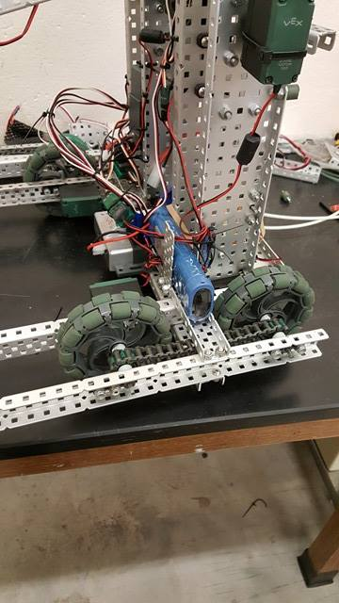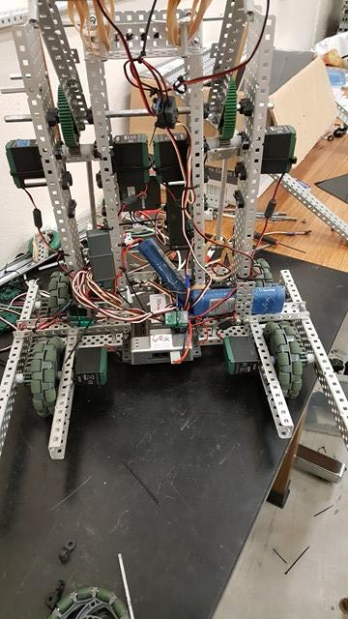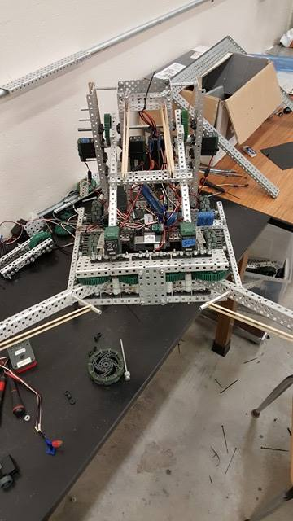

Goals for next time: Work on finishing claw Extension

Date: 12/23

Who Was There: Kyle, Noah, Max, Spencer

Goals: Claw Extension Finish

What was Done:

* Since we had our claw to the max distance it could be before, shortening the towers did not give us a large amount of new space to work with. We realized we had two options:
  + Solely use the small extra space given
  + Angle the new section of the claw at 45 Degrees
* Choice/Explanation: We decided to go with the second option, because while it also gives us extra space, it creates a way to better hold the stars and cubes, by creating a restraint to force the robot to stay within the constraints of the robot, and effectively allowing us to score a higher percentage of the game objects that we pick up. This extension of the claw allows us to pick up 3 stars or one cube extremely effectively, and has a maximum lift ability of 4 stars, or one star and one cube. However, we will put the extra two motors on the lift, and try to get those numbers higher.

**New Claw Design**

* We took off the spokes when we decided to move the lift towers inward towards the center of the robot. We were going to replace them today, but some of us were hesitant to do so because of the fact it was difficult to keep the spokes within 18 inches by 18 inches at the start of a match. However, Noah had an idea to create a consistent release mechanism so that the claws would stay within 18 inches until the claws moved: Using the green bending spokes in combination with standoffs, we will create a holding mechanism to hold the spokes in place, and using the initial use of the claws, by making the claws push the spoke past the standoff in question, thereby releasing the claw. [See Next Picture]
* 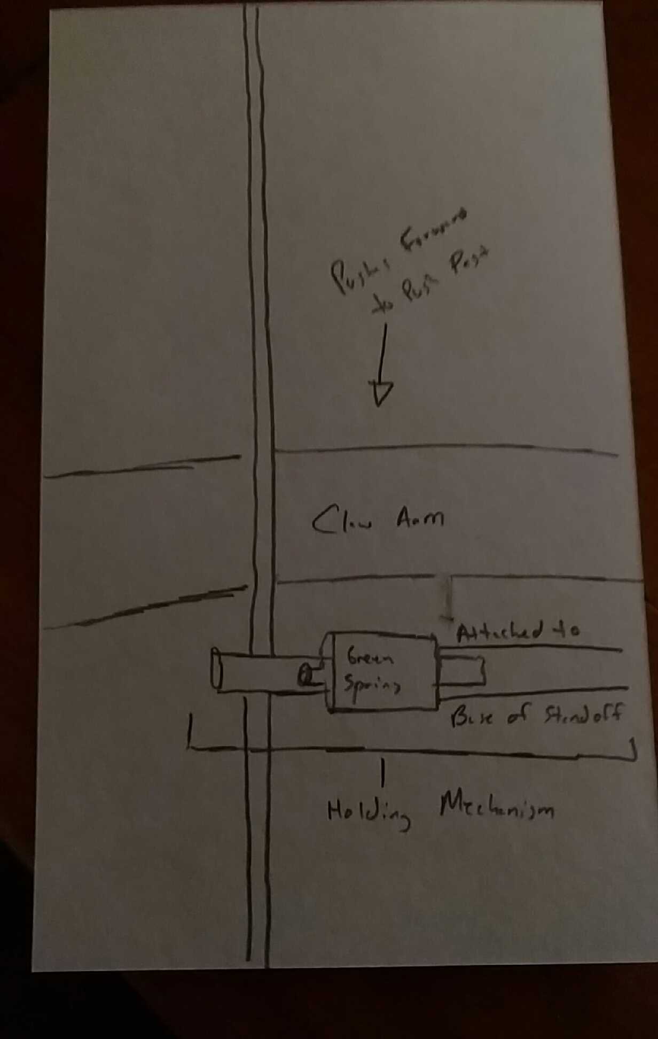

Goals for Next time: Add Spokes to claw setup, Add two motors to lift

12/26

Goals: Get some better form of Anti-tip on the robot

Who Was There: Kyle, Noah, Spencer

What Was Done:

* Removing weight will probably be a work in progress for a while, and thus, we will continue to keep finding parts which we can substitute for smaller versions, thus lessening the weight of our robot, but not compromising the structural integrity of our robot. In the spirit of this, we realized we could reduce the weight of our overall claw system - which helps us twofold – increasing the speed of our lift as well as the speed of our drive. We switched the 5 wide C-Channel that we currently had to 3-Wide, so as not to make it too small and compromise the support we give to the motors, yet still reducing the overall weight
* We realized we are tipping more than we should be when we are driving, and decided there were two options we could try the following:
  + Extend the drive length, in order to make us less likely to tip
  + Place a Bar on the front of the robot, so we are less likely to tip forwards
  + Create a held-back/released anti-tip system
* We decided to go with the first two options, as we realized the majority of our tipping problem stemmed from the fact that our drive was too short, and not supporting the center of gravity of our robot when it was lifting objects. However, by extending the drive forward, we will be able to support the center of gravity when we are lifting objects – at least to a greater extent than before. If we continue to have this tipping problem, we will consider a release system for the purposes of anti-tip.
* 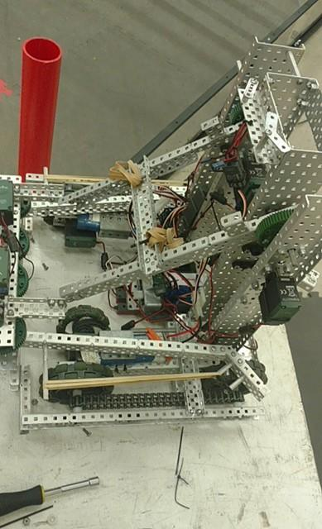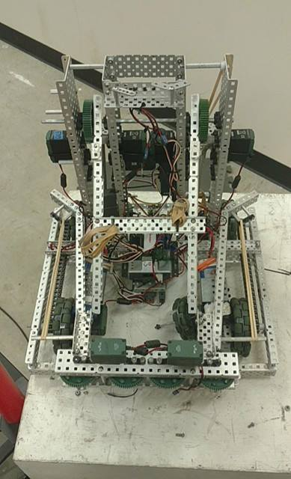

Goals for Next Time: Work on Intake Spokes

12/28

Goals: Work on Intake Spokes

Who Was There: Noah, William, Max, Kyle, Spencer

What Was Done:

* In an effort to raise the amount of game objects we could put over the fence at once, we unanimously decided we should put our remaining two motors onto our lift. While we already can lift four stars, we have the capacity for five, and in case the situation arrives, we would like to be able to lift that many stars in competition. On top of this, this will drastically increase the speed at which we can lift game objects over the fence, and increase the amount of points we can score in any given amount of time, helping us to defeat our opponent in competition.
* Since we had taken apart the claw, and subsequently had to take it off, and messed with part of the lift, we again had to maintain our wires. We worked for a while so that our wires were all zip-tied, and easy to be followed back to the cortex, so that we could replace our sensors and our motors when we needed to.
* In order to create more surface area contacting the stars and cubes, we decided to use C-Channel instead of axles for our spokes coming off from our claw. To add these onto the claw, and still keep them within 18 inches at the start of our matches, we used a homemade version of a hinge, using axles and a bearing so they could fall to the ground at the start of the match. We will have to create a system to release the spokes, but the spokes are currently on the robot.

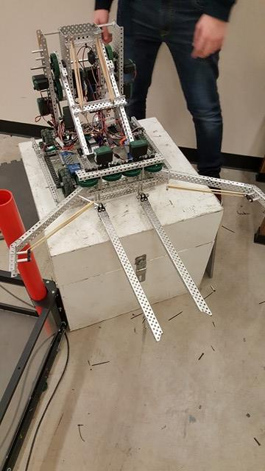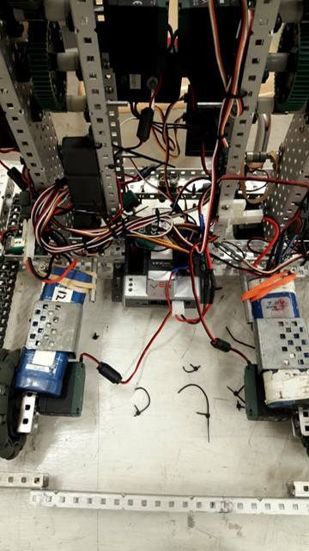

Goals for Next Time: Test Intake Spokes

1/2

Goals: Test Intake Spokes, and Driver Practice

Who Was There: Max, Kyle, Noah, Spencer, William

What Was Done:

* We began to test the intake spokes that we had put on last year. To our surprise, while they were able to handle stars fairly efficiently, it was not able to pick up cubes at an acceptable consistency – probably due to the fact the C-Channel is slightly raised compared to our previous spokes. While the C-Channel spokes were novel, we decided reverting back to our previous spokes would be the best idea, instead of trying to make the C-Channel work. On top of this, we got rid of the homemade hinges we had put on, and replaced them with actual hinges, as they work much better with the axle spokes we are currently using.
* We realized beyond time, there wasn’t an accurate way to measure how far the lift had gone up. We hadn’t even put a limit switch on it. We considered a myriad of sensors to put on the robot:
  + Quad Encoder
  + Potentiometer
  + Limit Switch
* Choice/Explanation: Due to the overall effects of encoder slip, and the necessary use of two ports, we decided against using the quad encoder. Furthermore, we decided against using a limit switch, as if we want to activate certain motors at a certain height (ie opening the motors to get more distance for the stars and cubes) we can do that, while we could not with a limit switch. Potentiometers are perfect for lifts due to their accuracy, and the fact that the limiting range of motor doesn’t matter for our lift – in fact, our lift only goes from 1800 to 4050 in range, so there is 1846 data points that will never even be accessed!
* Lastly today, we decided we needed to work on autonomous, so that we could win the autonomous bonus, and receive autonomous points during our next competition. We decided to create two autonomous programs: one to take the three stars in our far zone, and place them over the fence, and one to grab the cube, and put it over the fence. The only problem with these autonomous programs, is that since we currently do not have encoders on our robot, we are basing this on time, which will cause the program to start to fail as the battery voltage starts to fluctuate
  + For the first, we start in a backwards orientation. We move backwards while we open up our claw slightly, the turn in a sweeping fashion forward and right to move towards the stars, and carefully maneuver between the wall and the cube. Once we reach the stars, we move forward, then shut our claw when we have all the stars in our claw. Then we back up, and sweep turn 90 degrees, so we are close to our original position, back up to the fence, and dump the stars over to score points. For the second, we start in a forward orientation, open the claws, and turn in a sweeping motion to line ourselves up with the cube. Then, we move forward to pick up the cube, and turn backwards in a sweeping motion towards the fence, until we hit the fence, where we lift the cube over, and score points.

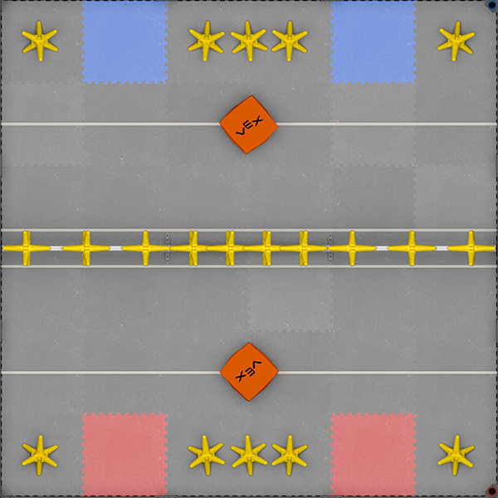

Goals For Next Time: Test Autonomous More

1/3

Goals: Driver Practice and Add Encoders

Who Was There: Kyle, Noah, Spencer, Max

What Was Done:

* Since we are starting to solely need to put the finishing touches onto our robot, we decided now would be a valuable time to have Spencer test out the robot by driving it. Through practice, Spencer can develop and polish both a routine of what to do when, and a sort of mental flowchart, so he will know what to do in each situation as it occurs.
* Since we didn’t have encoders on the wheels of the robot, William thought it would be a good idea to show us an idea he had involving the free spinning motor encoders. Since the encoders were not attached to a motor, we had a bit more leeway working with them, so we realized we could put them on a hinge. While this might seem detrimental, by using rubber bands, we can use this hinge to create a constant downward force on the wheels, thereby eliminating encoder slip, and giving us a more accurate sensor value. We mounted them on top of the front anti-tip bar, as that was the place we could fit them.
* 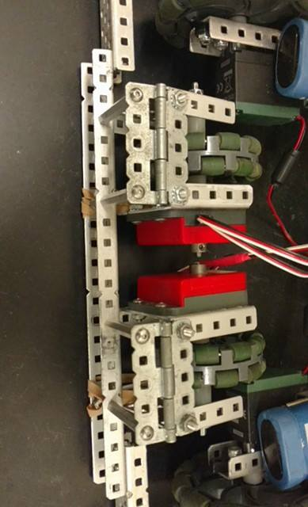
* We realized using limit switches for both determining when the lift was down, and for realizing if there were any stars or cubes in the claw. By doing this, we will eliminate the possibility of the lift skipping gears and getting off course. Furthermore, through the use of the claw limit switch, we can tell the robot to apply a slight hold speed while we are holding objects.

Goals for Next Time: Add Limit Switches, Fine Tune Autonomous Programs

1/4

Goals: Work on Autonomous

Who Was There: William, Noah, Kyle, Russell, Max

What Was Done:

* While we discussed putting the limit switches on yesterday, we never actually had time, and so the task fell to today. We mounted the lift limit switch on top of the free spinning encoder wheel mount, and used a rubber band so that the lift would hit the button before it went all the way down, so as to both stay at the value we want to, as well as to not damage the sensor. We placed the claw limit switch in the center of the edge of the claw gearbox, as that was the place we could most effectively mount it for our purposes. We know this might not be the most effective, but if we are holding a cube, or multiple stars, it should be pressed down, indicating a hold speed should be applied to the claws.

**Limit Switch Implementation**

* In order to get a more accurate determination of where our claw is, we replaced one of our claw motors with an IME, so that we could detect where the claw is in encoder ticks.
* Since we now have encoders, we realized we should program our autonomous, but use encoders instead for consistency. We went through both sets of autonomous programs, slightly altering them, and making them work with the encoder sensors we are using.

Goals For Next Time: Tournament Analysis

1/5

Goals: SMC Tournament Analysis

What Was Done:

* At our last tournament, we saw that the teams that were able to win most consistently were the teams that were able to overwhelm their opponents. Taking that in mind, we came up with two strategies to achieve that goal
  + Quickly and Efficiently score to the far zone in order to overwhelm the amount of points the robots will have to move over a larger distance.
  + Quickly and Efficiently score to the near zone to block the access to the fence for dumper bots.
* During the majority of this tournament, we believe we will end up walking a fine line between these two strategies, making judgement calls not just about scoring our own points, but determining how long it will take our opponent to reciprocate and descore our points based on our placement of the scoring objects.
* While we cannot hang, as we do not have a high enough gear ratio, our current ratio gives us speed over robots that do lift during the end of a match. Considering we should probably be able to shoot 3 stars from far zone to far zone (12 pts) faster than an opponent can high hang (12pts).
* Obviously, yet importantly, we need to be quicker than our opponent with scoring if we intend to win our matches.

Goal For Tournament: Get to Top 10 in Qualifying

1/5 Continued

* While the limit switch on the inside of the claw works, it only works a small percentage of the time. We spent the rest of the time today trying to figure out how we could possibly increase our ability to detect when we have an object in our claw. We came up with the following three solutions:

1. Strategically placed limit switch attached to a plate at the back of the claw
2. Limit switch that only goes down when weight is put down on the claw
3. Light or Line Sensor at the back
4. Sonar sensor to determine when an object is in the claw

* Decision: We decided to go with option number four. While most of these options send back a binary value – minus the light/line sensor – which only allows us to see only if an object is pressed up against the back of the claw apparatus. With the Sonar Sensor, we will be able to see when each object is within any distance, and manipulate the claw sensor accordingly.

Date: 1/7/17

Goals: Post-Tournament Analysis

Who Was there: All

What Was Done:

We decided, after the tournament today, to discuss our performance, in order to better plan what we were going to do to our robot in the future.

Drive Base:

Very Bad Bad Neutral Good Great

Explanation:

While during practice, the robot seemed to drive extremely smoothly, the robot tended to tip during matches. This is not a problem with the motors, but is a problem with the drive base. In order to fix this, we will have to extend the drive base to give it a larger base so it will not tip. Effectively, we will need to create some sort of anti-tip for our robot, which will be done shortly.

Lift:

Very Bad Bad Neutral Good Great

Explanation:

While our lift functioned as we wanted it to, it seemed as if it was performing slower than it should have. Considering we have a 1:5 gear ratio, and most teams are running a 1:7, we should have a quicker lift than other teams with similar claw designs, but we were not. It is possible the weight we were putting on the lift was too great, and was causing us to be slower than a robot with a higher torque ratio, but this is unlikely. We will need to go through each of our lift motors to check the internal gearing of them to see if we need to change our gear ratio.

Claw:

Very Bad Bad Neutral Good Great

Explanation:

While our claw wasn’t as large as that of some of the other teams, we were able to gather stars effectively using our claw system. We could effectively gather and lift 3-5 stars, which was more than most of the competition. When we did not encounter other problems, this was extremely helpful.

Autonomous:

Very Bad Bad Neutral Good Great

Explanation:

While our autonomous program didn’t start to function in the beginning of the day, and we had to make some small changes to the overall program, it began to work midway through the tournament and was able to consistently perform and score a net 6-8 points overall.

Date: 1/11/17

Who Was There: Noah

Goals: Possible New Lift

What Was Done:

* Since the STEM Club would not be open until Friday this work due to Finals occurring, and my overall lack of a difficult test schedule, I decided to take some metal home and work on a separate lift system that we think will be overall more effective. Since the rest of the team is not here with me, I will obviously not attach it to the actual robot, as we would like to make sure we have more time to practice and fine tune our current robot before we decide to dismantle it. However, building a new lift is a delicate process, so we had several different possible iterations of possible lifts to choose from, as we had to choose both a gear ratio, as well as a lift type.
* Gear Ratio
  + 1:5 Torque
  + 1:7 Torque
* Choice/Explanation:
  + I decided to build a 1 to 7 Torque lift. While a one to five is faster, we eventually will want to build a claw with even more space than we have now, so we can lift upwards of 8 stars, and while it is practical for speed purposes to have a more speed oriented gear ratio, being able to lift more stars will be more important than the overall speed at which you lift them.
* Lift Type
  + 2 Bar
  + Irregular 4 Bar
  + Inverse 6-Bar
* Choice/Explanation:
  + We decided to build an irregular four bar. While four bars are normally built in parallel bars, we will not be doing this, as to extend the range of motion of the overall lift system. While a two bar would give us more overall power, and a six bar would give us more overall stability, a four bar, we feel at least, will allow us to have the best of both worlds, by both having a stable and consistent lift, while also being able to lift quickly and efficiently.
* The rest of the time spent today worked around the building of this system, and the majority of the overall system was built.
* 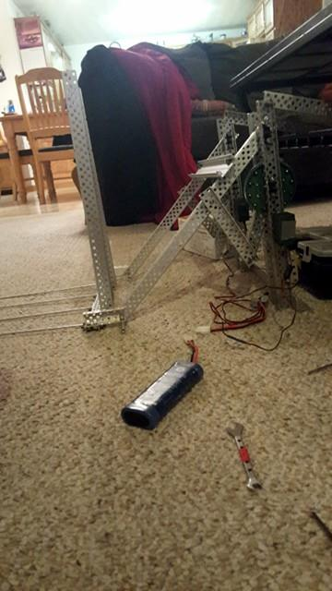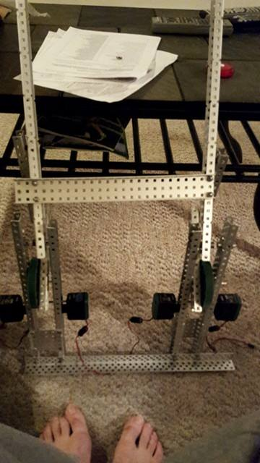
* Goals For Next Time: Discuss Putting this lift on the robot

Date: 1/14/17

Who was there: Kyle, Max, Noah

Goals: Discuss Claw System, Continue Working on 4-Bar

What Was Done:

* Firstly, we detached and took apart the free-spinning motor encoders, because we can build them in a better way, and there were a few problems with them:
  + Not enough force pushing them down to eliminate encoder drift
  + They were too close together, eliminating most turn radius, causing error
* We will make new modules later, as we have more pressing matters at hand today.
* Since we wanted to build a new lift system for our robot, we thought we should discuss the possibility of a new claw, and thus, decided to come up with a new claw vs old claw discussion. The major points and result of said discussion are below:

|  |  |
| --- | --- |
| Possible New Claw | Claw We Have Now |
| Stays in 18” : Hinges  Capacity: 5-7 Stars  Weight: Comparatively Heavier  Moves Through: Pneumatics | Stays in 18” : Wrap Around Robot  Capacity: 3-5 Stars  Weight: Comparatively Lighter  Moves Through: Motors |
| Result: Build New Claw; Attach if we believe it will function better than the old claw | |

* We decided if we had a new claw, we would allow it to move via pneumatic solenoids. Our main concern using pneumatics previously was the fact that you could only use a finite amount of actuations via a pneumatic system. However, after seeing several robots successfully use pneumatics, we realized it does have more positives than negatives to the overall system
  + Design Choice: We need to decide which type of pneumatics we would want to use.
    - Single Acting
    - Double Acting
  + Explanation: We decided to choose to use single acting pneumatics, due to the nature of this claw. Through single acting pneumatics, it will allow something to push back against the claw. If we have double acting pneumatics, and a large amount of objects within the grasp of our claw, we run the possibility of damaging the pneumatics. Furthermore, this will provide an overall better grip on the game objects.
* Since we determined the lift that Noah built will accompany this new claw when it is built, we decided to start the ground-work to attach the claw, for when it is built, and to start the overall claw. After talking about design, this encompassed the rest of our meeting for the day. In order to do this, we:
  + Put hinges on the 4-Bar System
  + Began to attach pneumatics to the base of the 4-Bar System
* Goals For Next Time: Work more on new claw

Date: 1/16/17

Members Present: William

Goals: Work on method to stop tipping

What Was Done:

* Since the majority of our problems at the previous tournament stemmed from the fact that we tipped within the majority of our matches, we realized that if nothing else, before our next tournament, we needed to address that issue, which is what I plan on starting today. I came up with two possible solutions for this problem:
  + Create some type of anti-tip system
    - Linear Slides
    - Drop Down from top in back
  + Lengthen the drive base
  + Choice/Explanation: I decided to create an anti-tip system, derived from linear slides and rubber bands, as solely lengthening the drive base to 18” is not feasible due to the orientation of our claw, and even if it was, solely extending the base to that length would not be extremely effective, as the center of gravity of our robot will shift quite drastically in certain situations, and we want to be effective as possible.

**Anti-Tip “Slide” System**

* In order to create this linear slide system, I started by putting the two linear slide mounts beneath the back plate of the robot, underneath the gyro. After that, I started to make the system. After trying to connect the two long linear slides at the level they were at, I quickly realized this was not feasible, due to the fact it would hit the cortex. In order to fix this, I put standoffs on the linear slides, and attached the linear slides together at a level where the connecting piece would go over the cortex.

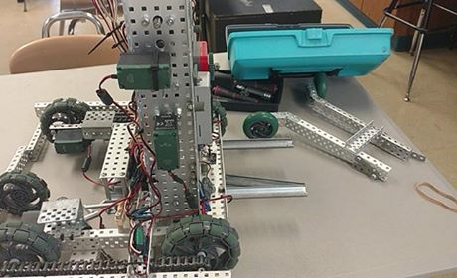 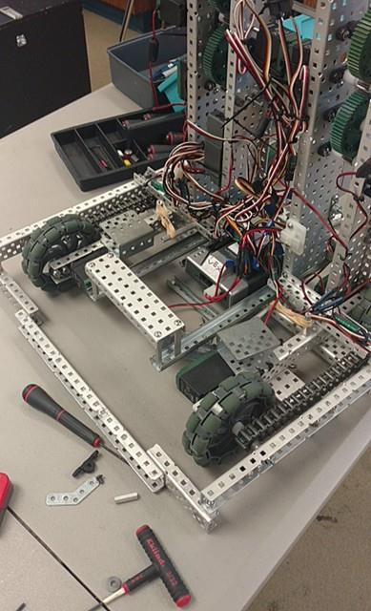

* After that was complete, I realized this system would be more effective if put lower, and therefore, moved the mount to underneath the cortex, which actually served the dual purpose of creating more stability for the system when it was pulled out. I plan on putting rubber bands on the system to pull the anti-tip out, and having it stay in through the claw.
* Goals For Next Time: Create release mechanism for anti-tip system

Date: 1/18/17

Members Present: William, Russell, Max, Noah, Kyle

Goals: Anti-Tip Release System, Work On New Claw

What Was Done:

* Due to the fact we had a snow day yesterday, and we have a limited amount of time until the next tournament, we unanimously decided that we would continue to work on the new claw and lift system, but would not use it for this upcoming tournament, as we will need to extensively test the new lift and claw before using it in competition, and we also need time to practice driving. Since we cannot have both, we decided having our driver’s being well-versed in the robot was overall more important.
* Since we had multiple goals, we decided to have two separate groups focus on two separate things: Kyle, Noah, and Spencer would work on the claw, while everybody else would work on the anti-tip release system.
* While we didn’t initially believe building an anti-tip release system would require much design, and therefore just went about building it, we went through several iterations before we found one that worked. First, we attached rubber bands to the connecting piece of c-channel on the system to the robot, and placed standoffs on both the bottom of the claw and the side of the anti-tip system, so when the lift raised, the system would release. That did not work, so we continued through several iterations:
  + Format:
    - (What Was on the bottom of the Lift) to (What Was on the Anti-Tip Release System)
      * Why we switched
  + Standoffs to Standoffs
    - Too much friction, lift can’t lift
  + Standoffs to White Spacers
    - Too much friction, lift can’t lift
  + Standoffs to Axle
    - Too much friction, lift can’t lift
  + Sponge Screw + Standoff to Axle
    - System slips off of the sponge screw
  + Sponge Screw + Standoff + Screw to Axle
    - Works, occasionally slips off of system
  + Sponge Screw + Standoff + Black Bearing to Axle
    - Works better, occasionally slips off of system, very rigid
  + Sponge Screw + Standoff + 5 Long One Wide to Axle (Current Iteration)
* This iteration, through the sponge screw, allows the lift to go up, as it creates flexibility even though a large amount of force is being placed on the hook, but is still able to hold the force due to the overall hook shape. Furthermore, since this is one wide, we are easily able to bend it to suit our needs on the fly during competition. This is by far the most consistent of all of the iterations we tried, and is the one we decided to keep on our robot.
* In order to justify making a new claw, we had to make the new claw while keeping in mind the failures of the old claw, while also having the successes of the old claw. We believe we have done this, as we determined the three things a claw should have, and built our claw accordingly:
  + Capacity
    - Since our new lift is a 1:7, and we as a team want to be able to carry more game objects, we knew we needed to increase capacity, and we did. When closed, the claw is only slightly less wide than the actual robot, and is probably longer than the actual robot. This is possible because, on a 2D plane, we plan on placing the claw at a 45 diagonal from the bottom left corner of the 18 by 18 box to the upper right.

18 inches

Claw Placement

18 in

* + Ability to Hold Objects
    - Because this claw has so much central space, one would presume it would be simple for stars to fall out the middle. We remedied this by placing four axles within the central part of the claw system, in order to create more contact points with the stars and cubes.
    - Furthermore, due to its design allowing for a large central space, we will be able to hold over 5 stars, which is certainly better than our previous claw.

**Closed Claw**

45 Degree Angle

For Max Capacity

* + Ability to Stay Within 18”
    - Since we plan on putting this on a hinge, at a 45-degree angle, we can create the maximum size of our claw, while maintaining our required space limits.

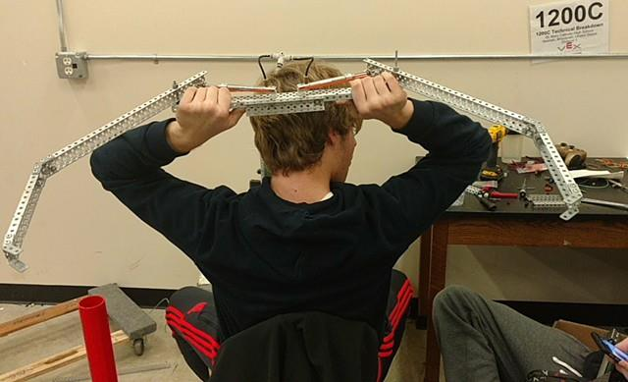

Goals For Next Time: Continue work on lift, Attach encoders to drive

Date: 1/19/17

Members Present: William, Max, Spencer, Kyle, Noah, Russell

Goals: Work on Lift, Encoders

What Was Done:

* Again, today, we split into two separate groups in order to achieve both of our goals today: William, Max, Spencer, and Russell worked on placing the encoders on the robot – as well as intermittently helping other teams through their issues – and Kyle and Noah worked on the lift system.
* Since our drive train is slightly irregular, we first had to figure out how we were going to attach the encoders to the drive train before we did. The following were suggested:
  + Free Spinning Encoders
  + Extend the chain, place encoders on the end
  + Place larger sprocket on the inside of the chain
* Explanation: Due to the placement of the anti-tip, there was zero room to place free spinning motor encoders. We actually tried to do option number two, as we thought option number three might possibly burn out the drive, as it would then hit a piece of c-channel, adding friction, but quickly realized this would cause the front motor not to be able to contribute to the overall chain power. We will test the drive tomorrow to see if the drive burns out because of our chosen option (#3), but we doubt it will.
  + Later, when we were about to leave, we realized we could add a free-spinning gear to put the chain back on track, so it will not hit the c-channel. We will implement this tomorrow.

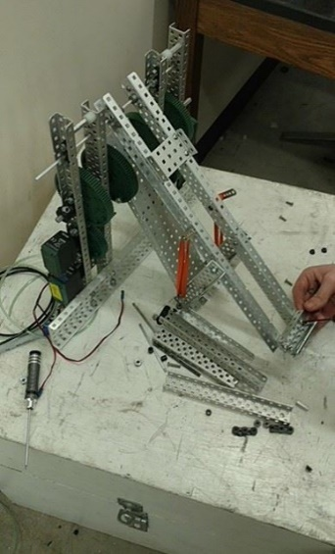

While working on the four-bar, we realized we had two prevalent options to choose from that were not considered when it was originally built:

* + Having a central arm
  + Having two separate arms connected mechanically.

Choice/Explanation: In order to fix a few issues with the current iteration of the lift, we decided to make a central arm, in between the two towers containing gear boxes. This allows less power to be lost in the overall power transfer while lifting multiple objects. While having two separate arms may add a bit more stability, using a piece of 5 wide c-channel allows us to have enough stability to be consistent. However, we will still need to test this, as without testing, this is pure assumption.

Goals for Next Time: Finish Encoder Addition, Driver Practice, Autonomous Programming

Date: 1/20/17

Members Present: All

Goals: Tournament Analysis

* Since we more or less have a similar robot to what we had at our previous tournament, with a few improvements, the points from the last tournament analysis still stand:
  + Two Possible Strategies
    - Quickly and Efficiently score to the far zone in order to overwhelm the amount of points the robots will have to move over a larger distance.
    - Quickly and Efficiently score to the near zone to block the access to the fence for dumper bots.
  + Mix these strategies, and react to the opponent’s overall robot and strategy.
  + Work to overwhelm the opponent quickly at the beginning, as having multiple extra game objects will cause most drivers to hesitate unless they have a large amount of practice.
  + While other teams attempt to hang, work to either get 3 stars, or a cube and a star from far zone to far zone, or more, as that will neutralize their point gain, as 3 stars, as well as a star and a cube, from far zone to far zone, nets 12 pts, which is the same as a high hang.
* We also needed to put one last finishing touch on the robot – we added a free spinning sprocket to each side of the drive to prevent the chain from hitting c-channel, and subsequently burning out the drive.
* The rest of the time today revolved around driver practice, and making a basic autonomous for tomorrow’s tournament.
* Since not all of us were practicing driving, the rest of us started to build a chassis that utilized 4 pieces of 35 long C-Channel, in order to have maximum stability. We placed 6 wheels on each side, and four motors on this chassis system, and chaining the each two outer wheels together.
  + The two inner wheels are free-spinning, and are connected to the encoder modules. While this is not as effective as our previous free-spinning encoder modules, these will still work to eliminate error.
  + The outer two wheels, connected by chain, are each powered by a Speed 393 Motor, giving us a fast drive, but still able to efficiently push objects, due to the chain.

Goals for Next Time: Win Award at Tournament!

Date: 1/21/17

Members Present: Caileen, Max, Noah, Spencer, William, Kyle

Goals: Post Tournament Analysis

What Was Done:

Drive Base:

Very Bad Bad Neutral Good Great

Explanation:

Our drive performed extremely well, and we never actually tipped, on account of the anti-tip system we integrated into our drive system.

Lift:

Very Bad Bad Neutral Good Great

Explanation:

Our lift functioned consistently, and would be in the “Good” category, except for one minor mistake. When the potentiometer was offset, it made the gears skip on the lift, and while that was an avoidable error, we want to make sure it certainly will be avoided in the future.

Problem: Offset potentiometer causes issues

Solution: Place limit switch at the bottom of the lift in order to compensate for any issues.

Claw:

Very Bad Bad Neutral Good Great

Explanation:

Beyond the times that the gears skipped an the motors became offset, our claw was consistently able to grab at least three stars at all times. However, we will want to fix the motor skipping issue.

Problem: Motor skipping, and screwing up the claw

Solutions: Possibly switch to pneumatics – our second bot has a pneumatic claw, and we will probably use it for our next tournament, and therefore, have the issue already fixed.

Autonomous:

Very Bad Bad Neutral Good Great

Explanation:

We only had one autonomous, that moved forward and knocked a few stars off the fence. While it was effective, it was not as good as we needed it to be. While this is understandable, as we were not able to set much time aside in order to program.

Problem: Need a better autonomous

Solution: Set time aside and work on autonomous when able to do so.

Other Observations:

* We did extremely well, having a qualifications record of 6-2, and each of those losses were because of faulty batteries. However, this just shows us we really need to check our batteries before we use them via the LCD Screen.
* We won the Amaze Award!

Our Goals For Next Tournament:

* 5 Stars Per Outtake Consistently
* Great Autonomous
* No Battery Issues

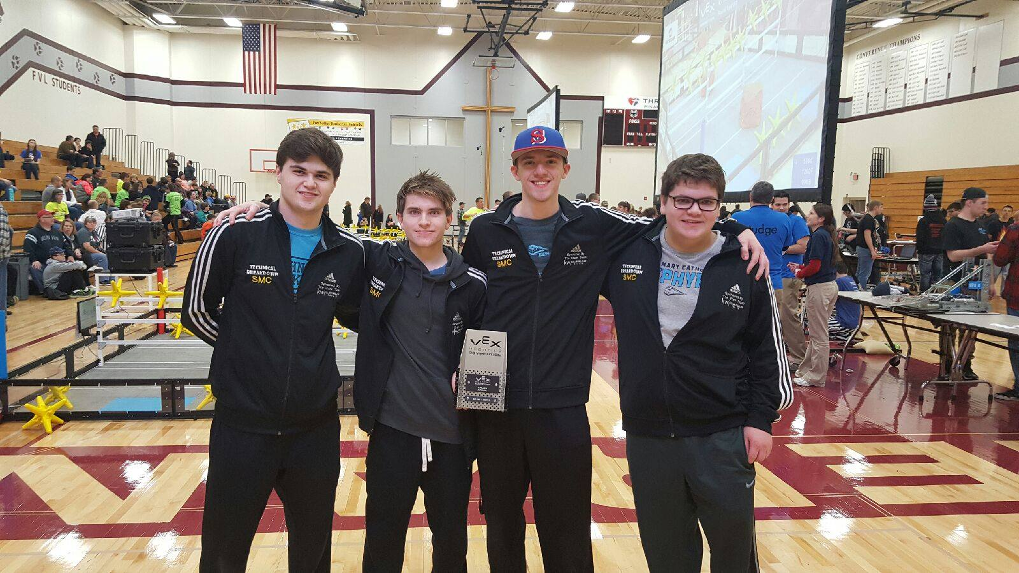

Date: 1/23/17

Members Present: Noah, Max, Spencer, Kyle

Goals: Work on New Robot’s Lift System

What Was Done:

* We began today by testing the irregular four bar system that we had planned to put on our new robot. However, we quickly realized we would not put that lift on, as it barely was able to lift up two stars over the fence.
  + This is not due to the archetype of the lift, as every other robot that is similar to the one we are using have been able to lift 5+ stars with this lift archetype.
* Since the irregular four bar that we had built was not seeming to give the overall system enough power, we decided to build our new lift archetype under the assumption that we had to do everything in our power to prevent power loss. This design philosophy manifested itself in two ways over the course of our building:
  + Instead of using High Strength Gears whenever we linked together motors, we used the slimmer gears, as those gears lose less power than HS Gears. They are more likely to get off track, but as long as we build the system so that it cannot get off track. Everywhere we did not have to link motors, we used a metal 12 tooth gear on the motor shaft, as those are extremely sturdy, and work with the High Strength 84 Tooth (We want High Strength on that as it will be holding our lift system up) to create our desired 1:7 gear ratio.
  + Secondly, we decided to create a one tower system, in order to reduce the overall amount of weight in our total system, while only losing a small amount of stability. We decided to compensate for that lack in stability by using a wider piece of aluminum C-Channel. We believe this overall design choice will give us a quick, yet stable lift.
    - Furthermore, this will allow us to more easily maintain our motors, as none of them will be on the inside of our lift system, which will make them easier to quickly dismantle, and check the internal gears.

**Planned Lift Gear System**

* 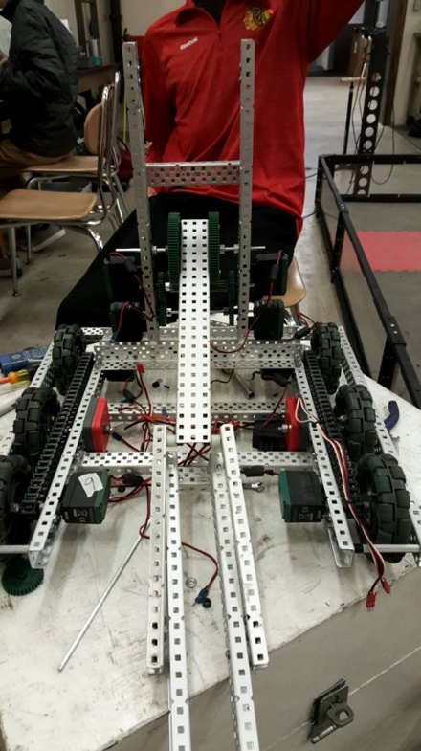We started to implement these design choices today, but were not able to finish before our meeting was over, and therefore, decided to finish it next meeting. However, we did finish:
  + Implementing the towers onto the robot
  + Attaching the entire four bar at one point to the lift system
    - 26 Long Low Bar
    - 18 Long Connecting Bar
    - 35 Long High Bar
  + Implementing 4 of the 6 motors that will be used in this lift system
  + Implemented an IME into the lift so we could see the position of the lift at all times
  + We need to:
    - Implement the other two motors above the 84 tooth gear
    - Finish attaching the entire four bar system

Goals For Next Time: Finish the Lift System

Date: 1/24/17

Members Present:

Goals: Finish and Test the Lift System

What Was Done:

* We started right away today by finishing the overall lift system.
  + We added a set of two motors to the top of the 84 Tooth Gear, thus completing attaching all six motors to the overall system.
  + We attached the other two bars of the irregular four bar to the top of the towers, and with that, the lift system was finished.
* After finishing this system, we decided to add on the claw. We came up with three possible ways of “dismounting” the claw from its original diagonal positioning:
  + Use of Hinge and rubber bands
  + Use of Hinge and pneumatics
  + Some other type of passive release
* Chosen/Explanation: While we could design a new passive release, we really don’t have the time to do so, and either of the first two options would work just as effectively. Furthermore, we do not want to waste any air that will be used for the claw, so we decided against using pneumatics, which left us with using rubber bands, which will suit our needs perfectly.
* After implementing the claw in this way, we decided to test our lift system. While it was able to lift well, there was a “dead zone” at the bottom of the lift where it would not move. We believe this issue is caused by the length of the lower bar, and tomorrow, will shorten it up, which will consequently change the angle of force at each instant, hopefully getting rid of the dead zone.
* Lastly, we added elastics between the two bars in order to help the lift as it goes up, so we can have a faster overall lift.

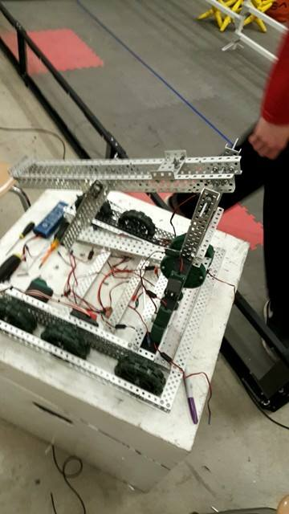 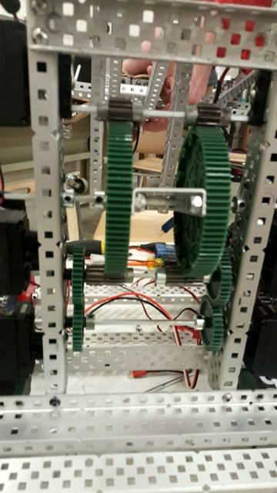

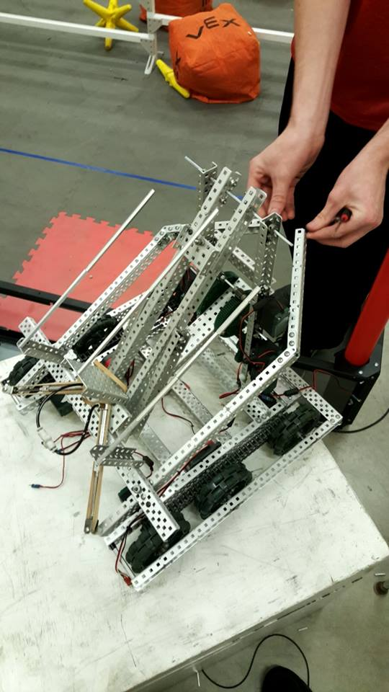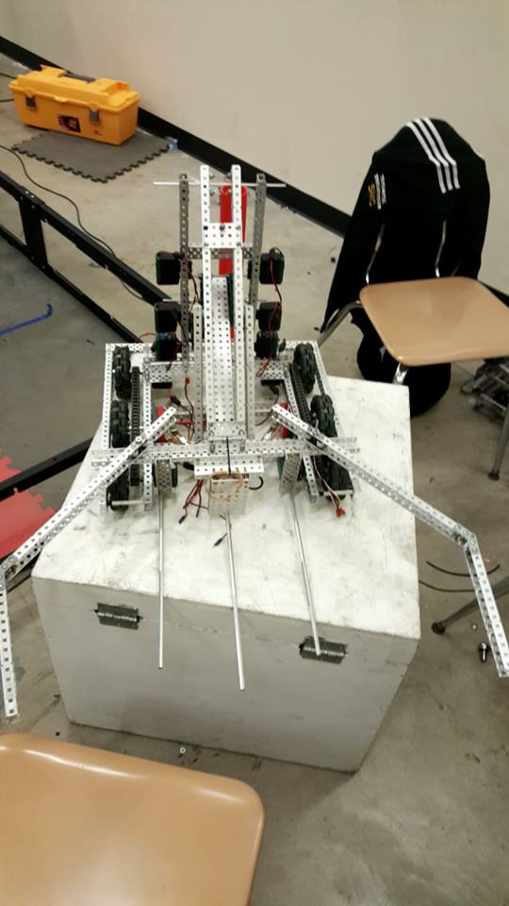

Goals For Next Time: Finish Lift System

Date: 1/25/17

Members Present: Max, Kyle, Spencer, Noah

Goals: Finish Lift System Build

What Was Done:

* At first we had troubles trying to get the lift fully extended, sometimes it would get caught on itself and go up only halfway. We were guessing and checking for the most part, but then we put the main bar that isn’t attached to motors up all the way, and attached the part that is attached to motors. After that we were able to extend our lift all the way up.
* Next, in order to create a bit more stability, added a HS 36 Tooth Gear above the top two motors.
* Lastly, we lowered the top bar of the lift, which will increase the power being put onto the top bar, but will lower the overall height it will go to – however, before, it was going too high anyways.
* After this, we plugged all of the motors into the cortex, and took note of all of them
  + Back Left Drive – Port 1
  + Lift bottom right – Port 2
  + Lift left bottom- Port 3
  + Front Right Drive – Port 4
  + Top Left Lift – Port 5
  + Top Right Lift – Port 6
  + Front Left Drive – Port 7
  + Lift Middle Left – Port 8
  + Lift middle right – Port 9
  + Back Right Drive – Port 10
* We also decided to add a few sensors onto our robot, beyond the IME and the free spinning encoders we already have added.
  + Added:
    - Potentiometer – Lift
  + To Add Yet:
    - Limit Switch (Possibly) - Bottom of Lift – Be able to adjust the relevant potentiometer variables in case the potentiometer gets off sync, as it did in the previous tournament.
    - Sonar (Possibly) – Inside Claw System – Be able to tell when objects are inside the claw
    - Gyro – Anywhere – Determining our angular position during autonomous
* After determining which sensors would be beneficial to us, we decided to test the lift again. We were able to carry five stars without struggling, but we started to tip, and thus, Noah and Kyle started to develop a design for a forward anti-tip system.

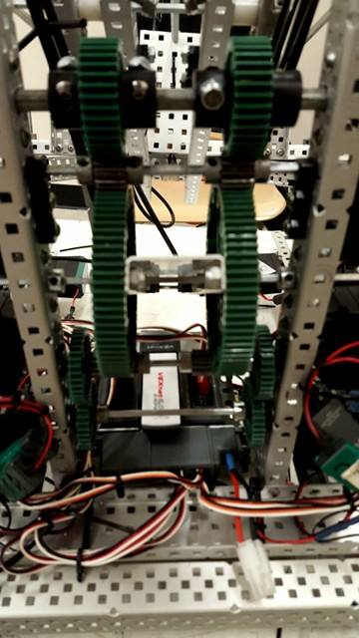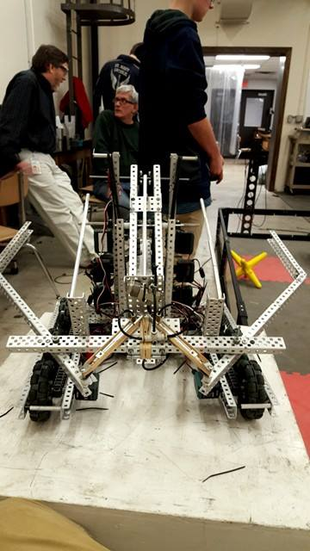 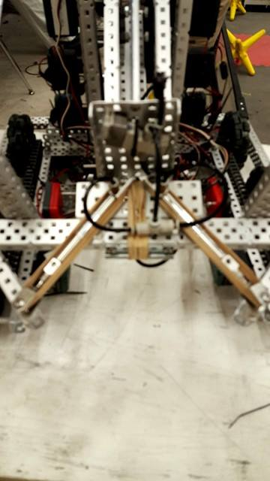 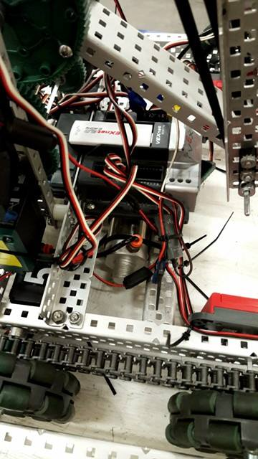

Goals For Next Time: Finish Wiring, Driver Practice, Autonomous, Forward Anti-tip, Possible Lift

Date: 1/26/17

Members Present: William, Spencer, Kyle, Max

Goals: Work on wiring the sensors of the robot

What Was Done:

* We wanted to make sure we had all the amenities of the previous robot on this robot – including the majority of the sensors. We added the following sensors in the following ports:
  + Potentiometer – Lift – Analog 1
  + Gyro – Overall Robot – Analog 2
  + 2nd Battery Voltage Sensor – Analog 3
  + Left Encoder – Drive System – Digital 1 & 2
  + Right Encoder – Drive System – Digital 3 & 4
  + Solenoid Sensors – Claw System – Digital 5 & 6
  + Possible Add on in Future – Lift Bottom Button – Digital 7
  + Possible Add on For Future - Ultrasonic on Claw – Digital 9 & 10
  + LCD Quadrature Scroller – Digital 11 & 12
* After testing the robot yesterday, we realized we would need a form of anti-tip – but for the front instead of the back. Because it was so effective at the previous tournament, we decided we would make a system similar to the one we had from the previous tournament.
  + In order to do this, we realized we would need to make more space for such a system, and thus moved the free spinning encoder wheels back two spaces.
  + We will work to implement this system tomorrow, as well as allow our driver to get more practice with this robot.

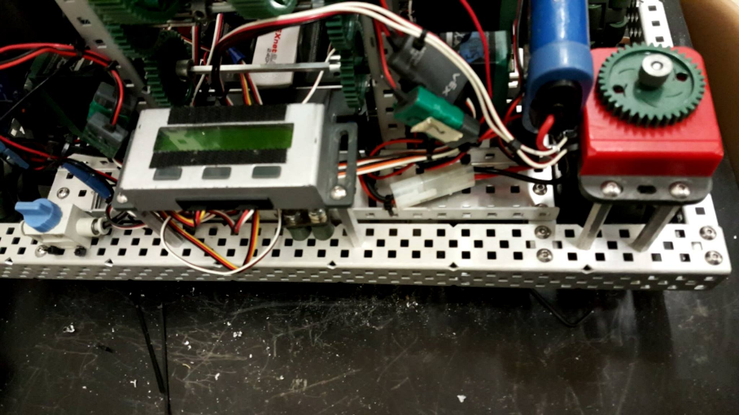

Goals for next Time: Driver Practice, Tournament Analysis

Date: 1/27/17

Members Present: Caileen, William, Noah, Kyle, Max, Spencer

Goals: Tournament Analysis

What Was Done:

* Tournament Notes:
  + In our first match, our pneumatic nut fell out of its position, causing our claw to be ineffective at best. We fixed this after the match, but this did cause us to lose our match.
  + Since we have a larger capacity than most, we will need to be able to use our ability to dump a large amount of stars effectively, and like most times, this is shown in two separate ways:
    - Overwhelm the robot itself, not allowing it to move, and/or blocking its path.
    - Place the stars as far away as possible from the robot’s, as we want to be able to make them take the longest amount of time for the opposing team to return the stars to our side of the field, if they do so at all.
  + If we can use the first strategy at the beginning, and work to overwhelm the robot back at the beginning of the match, we will be able to have a much easier match than we otherwise would.
  + While we thought about implementing a quick hanging mechanism today, putting on one that was rushed would make the system ineffective, and would probably cause more harm to our robot than good.
    - Especially since we only would want it just for the ability, as in most scenarios, moving game objects is a much more efficient way of scoring points.
  + In our last match, our solenoid became unplugged from the actual cortex, causing us to lose the match, and our spot in the tournament.
* Tournament Analysis:

Drive Base:

Very Bad Bad Neutral Good Great

Explanation:

Our drive performed extremely well, and only burned out in the elimination matches, but that was quickly fixed by switching out a motor

Lift:

Very Bad Bad Neutral Good Great

Explanation:

Our lift functioned consistently, and despite having a 1:7 torque gear ratio, we were still able to lift game objects incredibly quickly, and was instrumental in our ability to defeat other strong teams.

Problem: Offset potentiometer causes issues

Solution: Place limit switch at the bottom of the lift in order to compensate for any issues.

Claw:

Very Bad Bad Neutral Good Great

Explanation:

Switching to pneumatics allowed us to have a much more consistent claw, and allowed us to grab more stars. This helped us to win the majority of our matches. However, the fact that the pneumatic nut falling out cost us our last game, we need to keep better track of those.

Problem: Pneumatic nut validity

Solutions: Unknown at this time.

Autonomous:

Very Bad Bad Neutral Good Great

Explanation:

We only had one autonomous, that moved forward and knocked a few stars off the fence. While it was effective, it was not as good as we needed it to be. While this is understandable, as we were not able to set much time aside in order to program.

Problem: Need a better autonomous

Solution: Set time aside and work on autonomous when able to do so.

* Overall, while we wish we could have won the tournament, we were happy with our overall performance. Through today, we were definitively able to qualify for the Wisconsin State Tournament, and we still have one more tournament to qualify for the US National Tournament.

Date: 1/30/17

Members Present: Noah, Will, Kyle, Spencer

Goals: Drive Practice, Establish Goals next future tournament.

* First, we decided we needed to talk about what we wanted out of our next tournament. We all agreed about the fact that we either needed to win the overall tournament, or win the Skills Competition at this tournament, as it is the last chance we have to be able to qualify for the National Robotics Competition. In order to do this, we will work extremely hard at driver’s practice, and work to get a cumulative skills score of over 80 points.
* In order to achieve the above stated goal of winning the next tournament, we started driver practice right away.
  + First, we noticed our bottom left lift motor was burnt out, and so we promptly changed that motor.
  + After about 30 minutes of driving practice, Noah realized our lift’s bottom axle was bending too much, and that it needed to be fixed. In order to “fix” it, we found two possible solutions:
    - Remake our entire lift system so we utilize two separate towers in order to have a more stable lifting system.
    - Create a structure so that we create support for the axle in question.
  + Choice/Explanation: We decided to go with the second option, as that would not require us to rebuild our entire lift system – and we know our overall lift system functions, as it did extremely well at our previous tournament.
  + In order to achieve this added structure, we used a piece of 8 long C-Channel, and attached it both to the base of our robot in the middle of the axle that was bending, giving it structure in the spot needed most – giving us the effectiveness of a single gearbox with the structure of two. Unluckily for us, this covered our LCD Screen, and thus, we will eventually have to move that to a different location. After adding this, we continued driving practice until the end of our meeting.

**Implementation**

**Design**

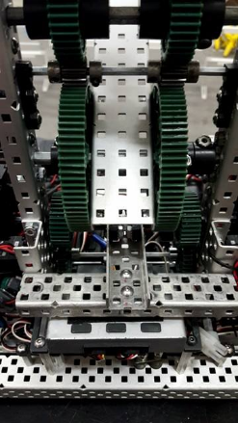

Goals for Next Time: Driver Practice

Date: 1/31

Members Present: Spencer, Kyle

Goals: Driver Practice

What Was Done:

* The majority of today’s meet focused on Spencer driving, and Kyle coaching/resetting the field. Through this, we were able to, and will continue to, find any issues that might come up, and find the way to best resolve them. One major unresolved issue came up from today’s practicing: tipping.
  + To solve the tipping issue, two solutions were presented:
    - More driver practice to work to not tip in match situations
    - Back anti-tip
  + Choice/Explanation: We decided to go with the first option, as while a hardware fix would solve our problems, but it would also cause a few other problems – namely that adding an anti-tip mechanism would cause us to have less mobility overall, and would not allow us to hang.
* After we brought up hanging, we decided to discuss the necessity of a lift function – as in lifting the robot on top of the pole.
  + As we have discussed before, hanging is not worth it during matches, as scoring 12 points is much easier to do by taking three stars from our far zone and place them in our opponent’s far zone.
  + Hanging in autonomous is effective, but depends on the situation, and probably should not be attempted, as if we miss, and tip over, we lose many prospective points.
  + Hanging in the Skills Challenge is the time hanging is worth the most, as every prospective point is important, as in the combined skills challenge, 24 of the 152 prospective points are only accessible through hanging.
    - Due to this analysis, we have decided to build a hang mechanism if we can, but only use it during the skills challenge.

Goals for Next Time: Check if we can hang / Driver’s Practice

Date: 2/1/17

Members Present: William, Kyle, Noah, Spencer, Max

Goals: Driver Practice

What Was Done:

* For the majority of the time today, Noah and Spencer took turns practicing driving, while Max and Kyle practiced coaching them, so that they could be as effective as possible during both the actual competition and during skills competition.
* While we were driving, we realized one of the issues that was causing us to lose a few valuable seconds was attempting to pick up stars while we were against a wall. We came up with two possible solutions to fix this issue:
  + Work to come in at a different angle when game objects are up against the wall.
  + Add wheels to the end of the claw.
* Choice/Explanation: We decided to go with the second option, as while the first option would work, it wouldn’t actually save us any time during the course of a match. These wheels reduce the amount of friction between the edge of our claw and the wall. It also allows us to have a little extra gripping power on our stars, due to the “extension” of the claw through this wheel.

**Claws With Wheels**

* We also decided to see if we would be able to hang. After attempting several times on the pole, and once by lifting up the chassis, and attempting to have the robot lift itself without the friction of the floor, but the robot was not able to lift itself.
  + While we do not plan on changing our robot, we understand what must change if we do intend to actually have our robot lift itself, and is demonstrated in this diagram:

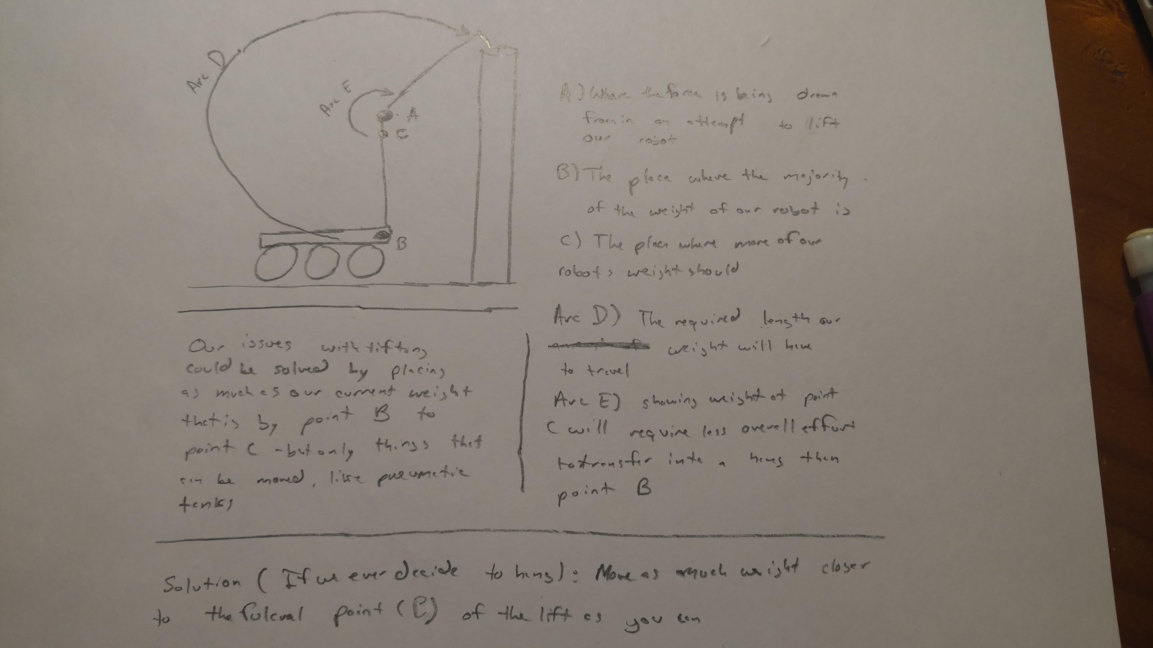

**See Given Sheet – I will give a sheet to you 2/7/17 because the photos doesn’t want to upload.**

* While all of this was happening, William worked on a project in order to make sure we didn’t lose any matches in fashions similar to the ones we had in previous tournaments – namely due to technical difficulties. Throughout this meeting, he created an extensive checklist to fill out before each match – an example page is provided both on the USB Drive on the Programming Journal, and at the front of this journal.

Goals for Next Time: Autonomous Programming / Driver Practice

Date: 2/2/17

Members Present: Kyle, Noah, Spencer, Max

Goals: Driver Skills / Practice

What Was Done:

* The entirety of today’s meeting was devoted to driver practice, with Spencer and Noah as the drivers, and Max and Kyle as the functioning coaches, in order to make us more prepared for the upcoming tournament.

Goals For Next Time: Driver Practice

Date: 2/4/17

Members Present: Kyle, Noah, Spencer, Max, William

Goals: Driver Skills / Practice

What Was Done:

* The entirety of today’s meeting was devoted to driver practice, with Spencer and Noah as the drivers, and Max and Kyle as the functioning coaches, in order to make us more prepared for the upcoming tournament.
* William worked on code to help create a TrueSpeed array, in order to create a more linearized response system for the robot’s drive. as that was the first thing he wanted to do in regards to the programming of the robot.
  + The last 15 minutes of this meeting were used for helping William take the robot to his car, as he plans to make his TrueSpeed array at home. If you would like to know more about the creation of the TrueSpeed array, all the relevant data will be within the Programming Journal.

Goals For Next Time: Work on Autonomous / Driver Practice

Date: 2/6/17

Members Present: William, Kyle, Max, Noah, Spencer

Goals: PID, Driver Practice

What Was Done:

* Half the time during this meeting, the robot was being used for driver practice, with Noah and Spencer practicing, and Max and Kyle coaching, and the other half, William was working on the PID Drive Values
* While we will not use PID on the drive for driving purposes, it will be very helpful to use it to create a more accurate autonomous program.
  + William tuned the P, I, and D values for the PID system for the drive, and it was accurate with various distances, and different weights within the lift.
  + After this, William tuned a PI Control Loop for the lift, in order to hold the lift up effectively during the autonomous period, as we will likely be carrying a large amount of weight during that period.
    - For a more indepth review of the overall PID system, look at today’s date in our Programming Journal.



Goals for Next Time: Driver Practice

Goal For Next Time: Work on Autonomous

Date: 2/8/17

Members Present: William, Noah, Kyle, Max, Spencer

Goals: Create a more accurate release mechanism, driver practice, autonomous programming

What Was Done:

* We started to work on the autonomous period’s programming, but quickly realized our release mechanism was not consistent enough to be used in competition.
  + While we knew we could switch to pneumatics, doing so would cost our claw some of its precious air, and we cannot afford that.
  + We went through several iterations of attempting to improve the consistency of the claw release mechanism:
    - A) Adding more rubber bands
    - B) Changing the placement of the rubber bands
    - C) Making the force of the rubber bands perpendicular to the claw in order to get more force to bring it down.
      * Option C worked most consistently, and thus, we implemented option C

A Diagram B Diagram C Diagram

* After this, we decided driving practice was the next most important thing to do, and thus, Noah and Spencer both worked with the coaches present (Max and the other driver) in order to prepare them for the chaos of matches.
* After this, we planned to start programming our autonomous program. However, our cortex started to overheat, and we realized we had to switch out the cortex.
  + We grabbed one of our club’s extra cortexes, and started the process of replacing it.
  + William made a run to Walmart to get zip ties so we would be able to maintain the wires while we were switching them.
  + We tested the cortex afterwards, and realized the one we grabbed did not send voltage through motor ports 2 and 9. We found another cortex, and decided we would fix it at our next meet.

Goals for Next Time: Replace Cortex

Date: 2/9/17

Members Present: William, Noah, Kyle, Spencer

Goals: Rewire Cortex, Autonomous Programming, Driving Practice

What Was Done:

* Obviously, the first thing we did today was finish replacing the cortex (for the second time). We made sure the code we were running on the cortex had nothing to do with it overheating, and ran it on a separate cortex for over a few minutes with the same level of intensity, and no overheating was felt, and thus, we believe the overheating was due to the cortex’s age and use.
* Again, since a tournament is coming up soon, we realized more driving practice would be a good way to spend our time, and thus, Noah and Spencer practiced driving while the other team members watched footage of recent tournaments in order to determine strategy for the upcoming tournament.
* After working on driving, we decided to work on our autonomous program again. We came up with two main potential autonomous programs we would like to use for the upcoming tournament:

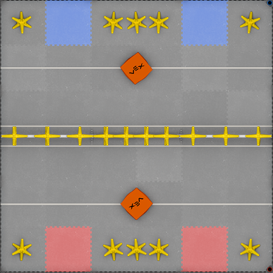 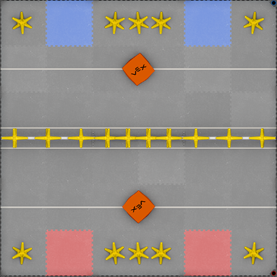

* In order to create these autonomous programs, we first realized we needed to tune our PID constants a bit further than they were. The results were
  + Drive – P: 0.5 I: 0.0001 D: 0.17
  + Lift – P: .05 I: 0.00003
* After tuning those constants, we finished the majority of the first autonomous, up until the point that it launches a star and a cube.

Goals for Next Time: Pre-Tournament Analysis

Date: 2/10/17

Members Present: William, Noah, Kyle, Max, Spencer, Caileen, Russell

Goals: Tournament Analysis

What Was Done:

* Through our discussion today, we made an important realization about the necessity about the strategy we need to implement. We need to take into major consideration the cycle time of our opponent robots – or the amount of time it takes them to lift up their lift and score points on our side of the field.
  + If an opposing robot has a faster cycle time than our robot, we need to do as much as we can to slow down their cycle time – and this means one of two things: either throw stars as far away from opponents as possible in order for it to take them longer to grab the stars, or throw the stars in their way in order to slow down the time it takes them to get to the fence.
  + If an opposing robot has a slower cycle time than our robot, we have to work to keep it that way, but work with a heavier interest in scoring more points into the far zone, in order to cement in our victory.
* Through our pre-tournament checklist – and amendments made to that checklist – and the fact that our robot has a good cycle time, we will not lose matches due to technical issues, and will have a chance to win most of the matches we will be a part of, and therefore, we believe we will have a very competitive robot at this tournament.

Goals for Tournament: Win

* After that, we worked on autonomous mode. While the PID seemed very finnicky, we were able to make a simple autonomous program, which worked like this:



* After that, we began the planned autonomous skills run, but due to how much time it took to program, we were only able to program up to the asterisk.



* Ill just write these in myself, can’t really do it on a computer.
* After that, Noah took time to practice driving, and worked especially to make sure we would not tip in the middle of the match. He did not tip at all, which is a great indicator about tomorrow’s tournament! However, there were a few close calls.

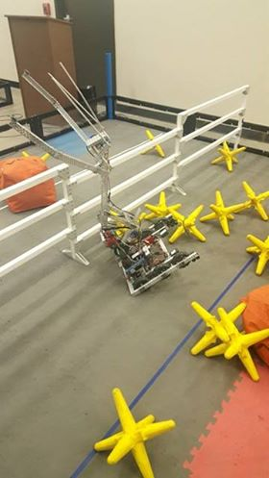

Date: 1/7/17

Goals: Post-Tournament Analysis

Who Was there: All

What Was Done:

Drive Base:

Very Bad Bad Neutral Good Great

Explanation:

The drive caused us no issues throughout the day. While it was not the fastest drive at the competition, it suited our needs extremely well, and did not burn out on us, as it has in past tournaments.

Lift:

Very Bad Bad Neutral Good Great

Explanation:

The extra support we added to the overall lift mechanism helped tremendously, and our lift never felt as if it were under immense stress during competition.

Claw:

Very Bad Bad Neutral Good Great

Explanation:

While we had a bit of an issue with one of the pneumatic pistons during our semi-finals match, our claw was able to lift and effectively hold a large amount of stars, or hold two cubes at once.

Autonomous:

Very Bad Bad Neutral Good Great

Explanation:

Due to unknown circumstances, the right encoder got a lot of dust inside of it, and therefore, the entire PID system was thrown off. More than likely, this is what was causing the PID to be finnicky when we programmed the robot yesterday. Because of this, the autonomous program did not function. However, we were luckily able to program a last minute autonomous based on time for our final matches.

Date: 2/13/17

Members Present: Max, Noah, Spencer

Goals: Discuss new Drive System

What Was Done:

* Noah brought up the possibility of us integrating a drop-center drive into our current robot, while this has several benefits over our current H-Drive, there are some drawbacks:
  + A drop center drive is a drive system that the middle of the drive is powered, while the edges of the chassis are not. In the way we will implement it, it will function as a “turn-table,” so at all times, the robot will be on the front two, or back two wheels

|  |  |
| --- | --- |
| **H - Drive** | **Drop Center Drive** |
| More Torque due to ability to chain together motors | Some Inherent Power Loss Due to Gearing |
| Standard and Reliable | Less Tip Prone |
|  | More Inertia For Launching Stars |
|  | Better for Overall Turning |

* We decided we would build a prototype of the Drop Center Drive, in order to see if we liked it. If we do, we can integrate it into our robot, but if it does not function well, we will just not use the idea.
* The rest of the time was spent building the prototype, and we finished a rough prototype:

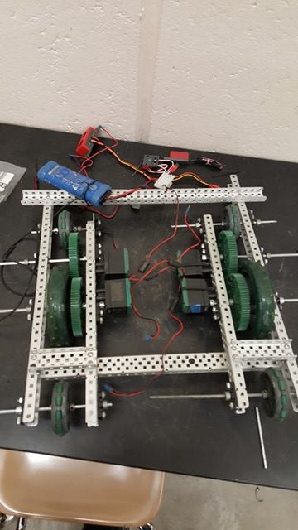

Goals For Next Time: Continue work Drop Center Drive

Date: 2/14/17

Members Present: Max, Noah, Kyle

Goals: Drop Center Drive

What Was Done:

* Noah and Kyle worked on the Drop Center Drive, in order to make it more suitable to be driven, so we can compare it to the drive we currently have.
* Max realized it would probably be a good idea to have a computer model of our robot, and so he started to build one in Google Sketchup.

Goals For Next Time: Program Drop Center Drive

Date: 2/15/17

Members Present: Noah, Spencer, William, Max

Goals: Drop Center Drive

What Was Done:

* William worked on programming the overall Drop Center Drive. Due to a finnicky controller, which made us believe there were errors in the wiring, this took him longer than we expected. However, we did eventually get to test out this drive system. It seemed to be slower than we had expected it to be. We will do a hardware check to see if this can be remedied by fixing a simple issue, or whether it is an issue of the actual drive.
* Spencer and Noah worked on improving our claw’s deploy. While before, we were using a specific method in autonomous to release the claw, by utilizing the weight of the preload, by adjusting the rubber band tensioning mechanism on our claw, we are able to get a consistent release without any other outside aid.
  + Two main things were done: 1)The extension of the bottom of the claw – by adding a small amount to the back of the claw, the force by the rubber band will be more effective, as it will be coming onto the claw at a right angle, making it most effective. 2) Extension of the length of rubber bands – By moving the place where the rubber bands farther back on the lift, there is more force attempting to pull the claw down then before, making the system more consistent.
* Max continued to work on the Google Sketchup model of our robot, and got a fair amount of the work on the virtual chassis done today.

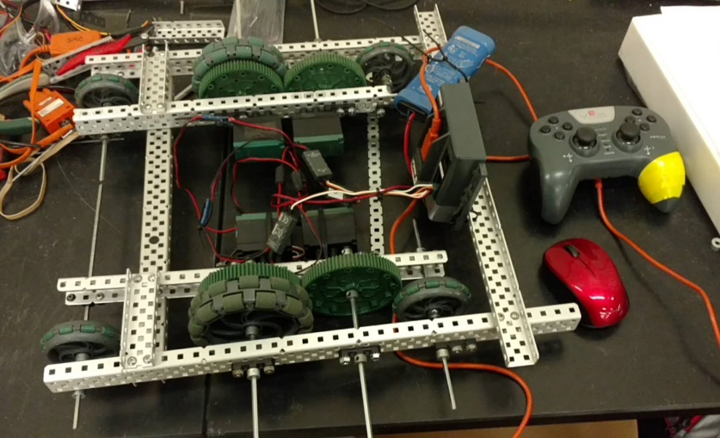

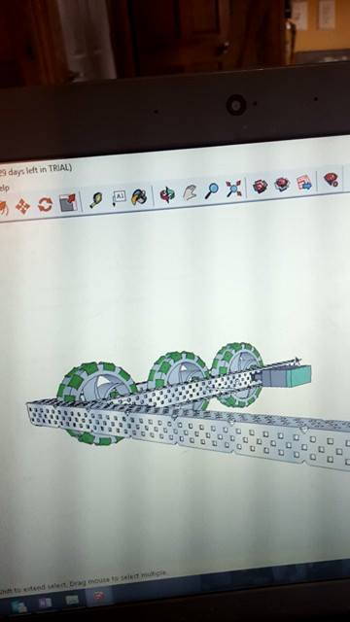 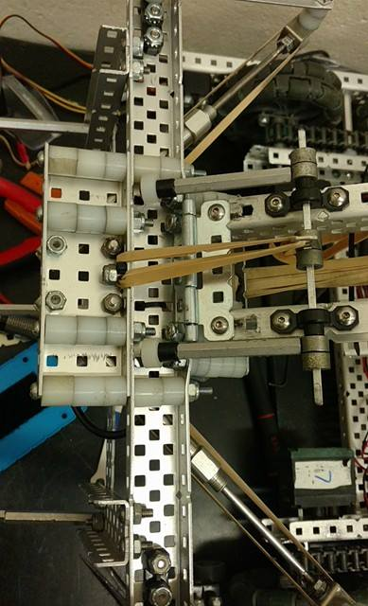

Change #1 to Claw, Written about above

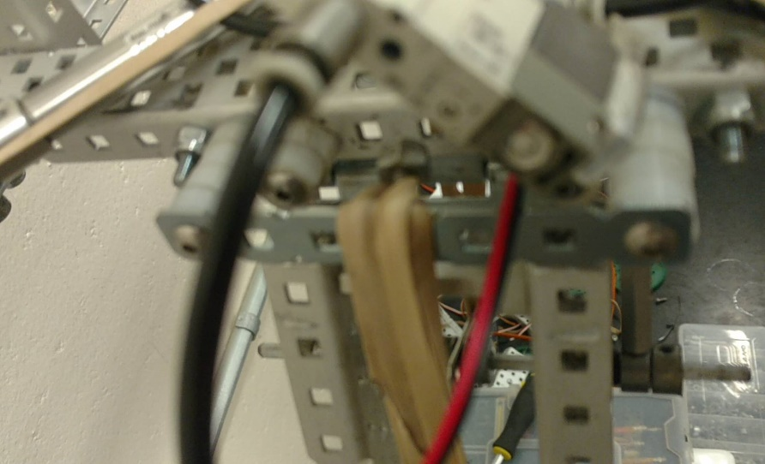

Below is Change #2 to the claw, written about above

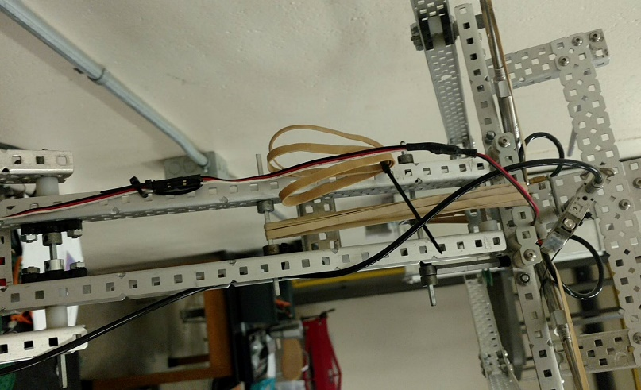

Date: 2-16-17

Members Present: Max, Will, Spencer, Kyle, Noah

Goals: Make Lift Better

What Was Done:

* In order to better support the lift when it is at the top of its lift cycle, we needed to add more support on the bottom axle. We found doing this helped dramatically with our overall lift, especially at the top.
* After fixing this issue, we spent the rest of the time on Driver Practice.
* Max spent more time working on the Sketchup of our Robot. While he has been working on it at home, he got a good amount of the lift done today.

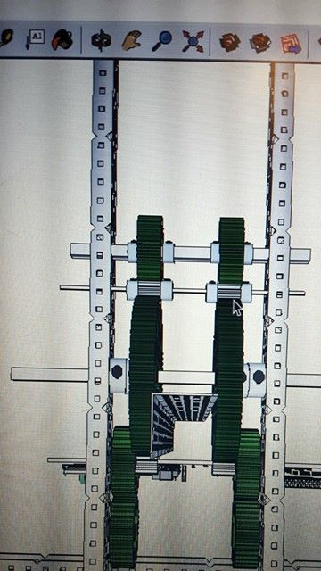

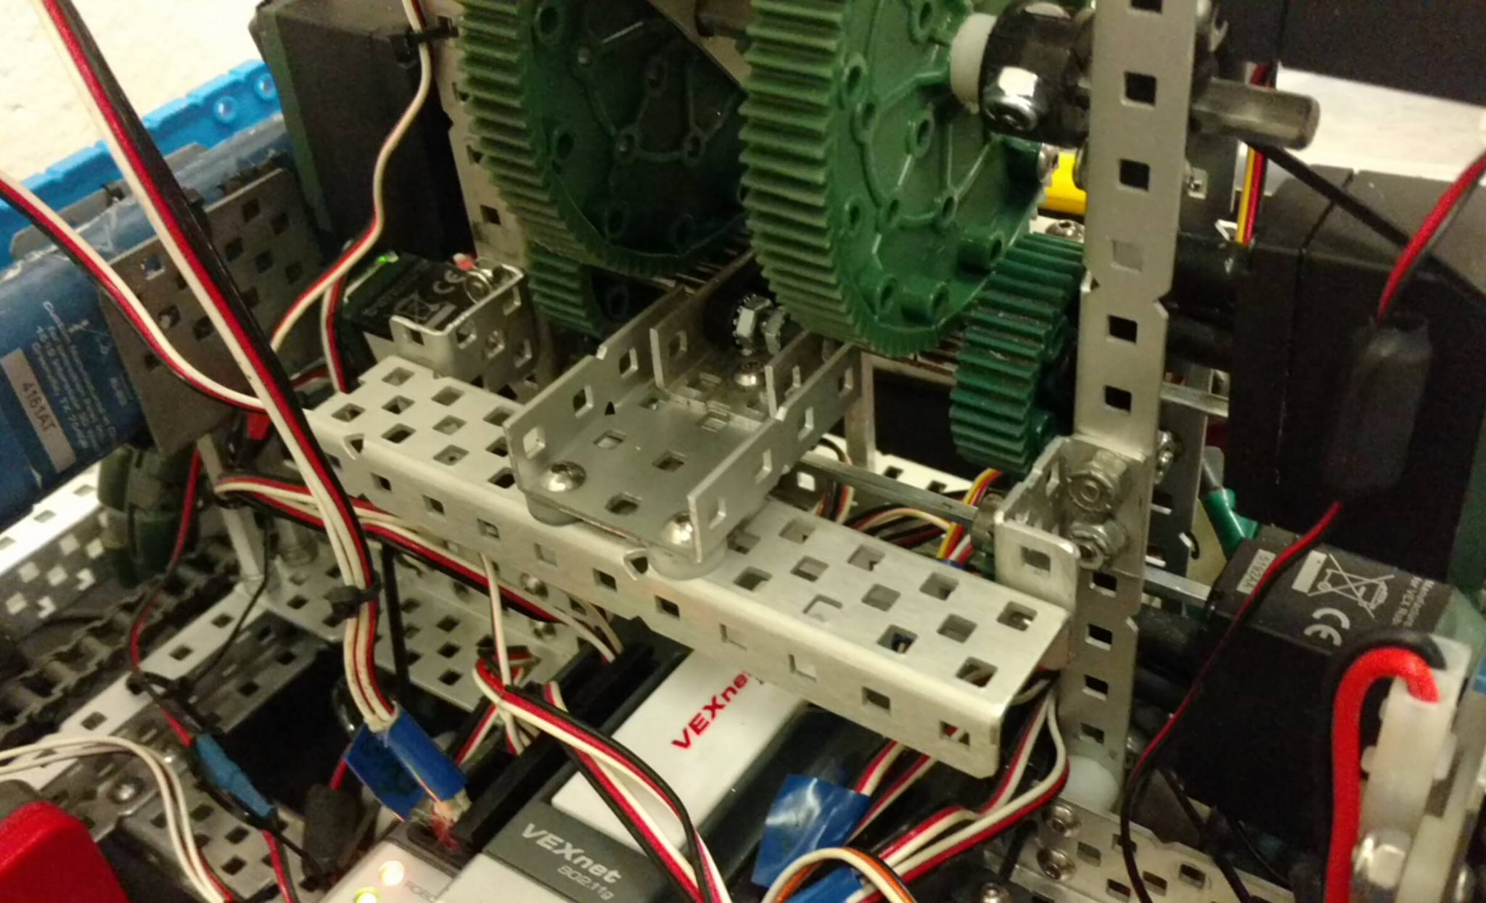

Date: 2/17/17

Members Present: William, Kyle, Spencer, Max

Goals: Autonomous

* We worked on, and finished another autonomous program today, which we made so that we will be more competitive at our upcoming state tournament
* Due to our previous experience with PID, we decided to not use the PID we have, so that we would not have to deal with the issue we dealt with at the last previous tournament.
* Obviously, we will work to create more autonomous programs in the future, in order to be even more competitive.
* The autonomous works as follows – again, will draw it in.



Goals for Next Time: Driver Practice, Autonomous Testing

2/18/17

Members Present: William, Noah, Spencer

Goals: Driver Practice

What Was Done:

* Noah worked on driver practice.
* We did tests on the lift, to see the maximum value of stars and cubes we could lift. We determined, at maximum capacity, we could lift:
  + 10 Stars
  + 3 Cubes
  + 1 Cube and 3 Stars
  + 2 Cubes and 1 Star
* Due to time constraints, William is going to take the robot home, and work on some autonomous programs there.

Goals For Next Time: Driver Practice

UPDATE: William got a 102 Degree Fever, so he will be unable to make another autonomous program today.

2/21

Members Present: Max, Spencer, Kyle, Noah

Goals: Momentum Tests

What Was Done:

* In order to put more momentum into the objects we are throwing, we decided to put a stopper, made of standoffs, to stop the lift before it starts to decelerate, to apply the maximum momentum to the game objects. However, while that sounds like it would work, we wanted to be able to make sure it would work, as there is the possibility our methodology is flawed.
* In order to test this, we created a system of trials. Testing the lift while having 1,2,3,4,5,6,7, and 8 stars, with three trials for each number of stars, both with and without a stopping mechanism. The results were recorded on a white board, and are shown below.

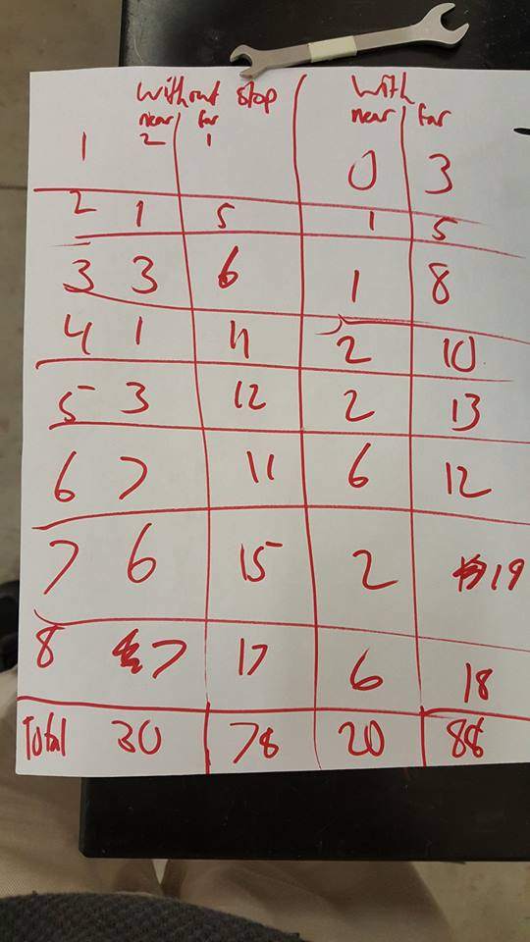

* It appears the stopper did its job. However, the amount of the increase was certainly within the margin for error, so we will perform more tests.

Goals For Next Time: Test Stopping Mechanism

Date: 2/22

Members Present: Max, Kyle, Spencer, Noah

Goals: Wiring

What Was Done:

* While our wiring is adequate, we need to have a better overall system so that we can quickly change faulty motors and bad wires whenever we need to, and know where they are supposed to go. Because of this, we decided to rewire the robot.
* When we began to rewire the robot, we realized it might be a good idea to color code the wires using the multi-colored zip ties we had, in order to help us know what wires served what purpose. We decided to do this, and came up with the following color scheme:
  + Blue = sensors
  + Yellow = drive motors
  + Green = lift motors
  + Orange = pneumatics
* We finished this wiring before the meeting was done, but due to the extensive nature of the task we were performing, we didn’t have time for anything else.

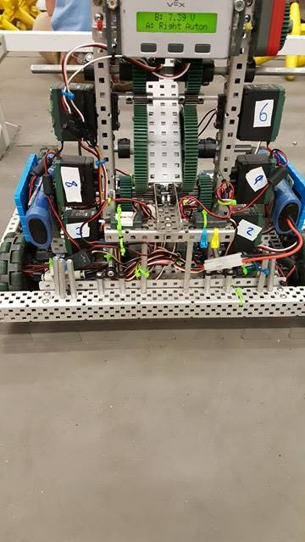 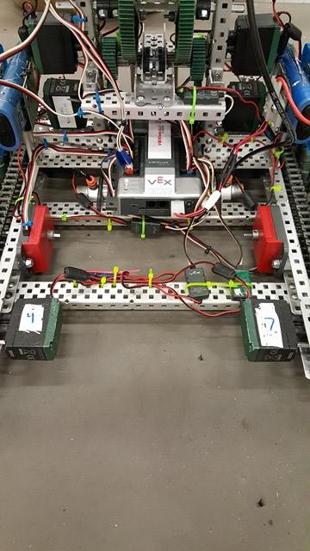

Goals For Next Time: Driver Practice, Autonomous

Date: 2/23

Members Present: Max, Kyle, Spencer, Noah

Goals: Driver Practice

What Was Done:

* Practiced driving with coaches.
* While not exactly as tedious as the tests we did on 2/21, overall, the ability of the lift to send objects into the far zone has increased, at least slightly, and therefore, we plan to keep it on.

Goals For Next Time: Autonomous Programming, Driver Practice

Date: 2/24

Members Present: Max, Kyle, Spencer, Noah, Will,

Goals: Driver Practice

What Was Done:

* Practiced driving with coaches.

Goals For Next Time: Driver Practice, Autonomous Programming

Date: 2/25

Members Present: Kyle, Spencer, Noah

Goals: Scrimmage! Object Protection

What Was Done:

* In order to prepare for the upcoming Wisconsin state tournament, we decided to have a friendly scrimmage with some nearby teams. 536C, 536B, 5062A, and SMC teams participated. While clearly we wanted to use this as a test of our robot’s strength, we also chose to use this opportunity to analyze strategy for the upcoming tournament. These were the key takeaways from this scrimmage:
  + Our robot is able to hold its own. However, for matches where we will be against two well-built back-dumping claw styled robots, we either need a partner who:
    - A) Has a similar scoring cycle time to a claw back dumping robot
    - B) Is able to play extremely defensively, and cut down the offensive cycle time of the robots we are facing
* In addition to the scrimmages, we also realized one other problem our robot has. While it is small, we realized we may as well deal with it, before it affects us in a match. We need to make it less likely that a star or cube will go under our lift system. We thought of a few possible solutions:
  + Work to maneuver around the stars so that we do not get stars stuck inside of our robot.
  + Use our available polycarbonate sheeting to create a type of shield.
  + Use aluminum plating to create a type of shield.
  + Chosen / Explanation: We decided to go with the 2nd option, due to its ability to actively keep stars out, which made it better than the first option, as well as the minimal weight of the polycarbonate, which made it better than the 3rd.
* Max worked on the CAD for the claw.

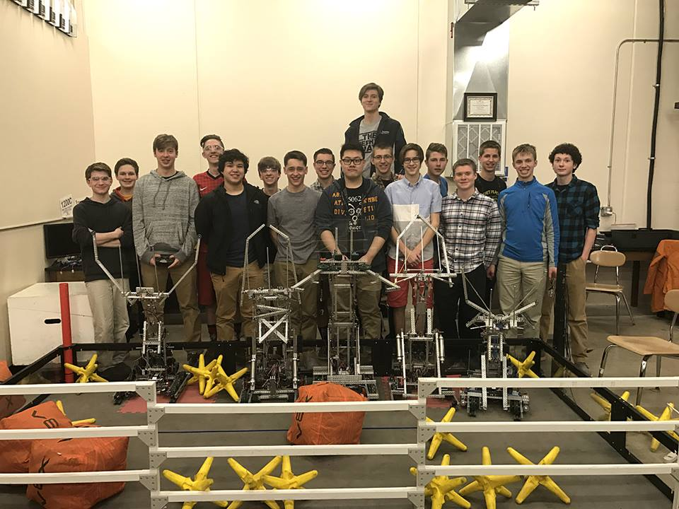 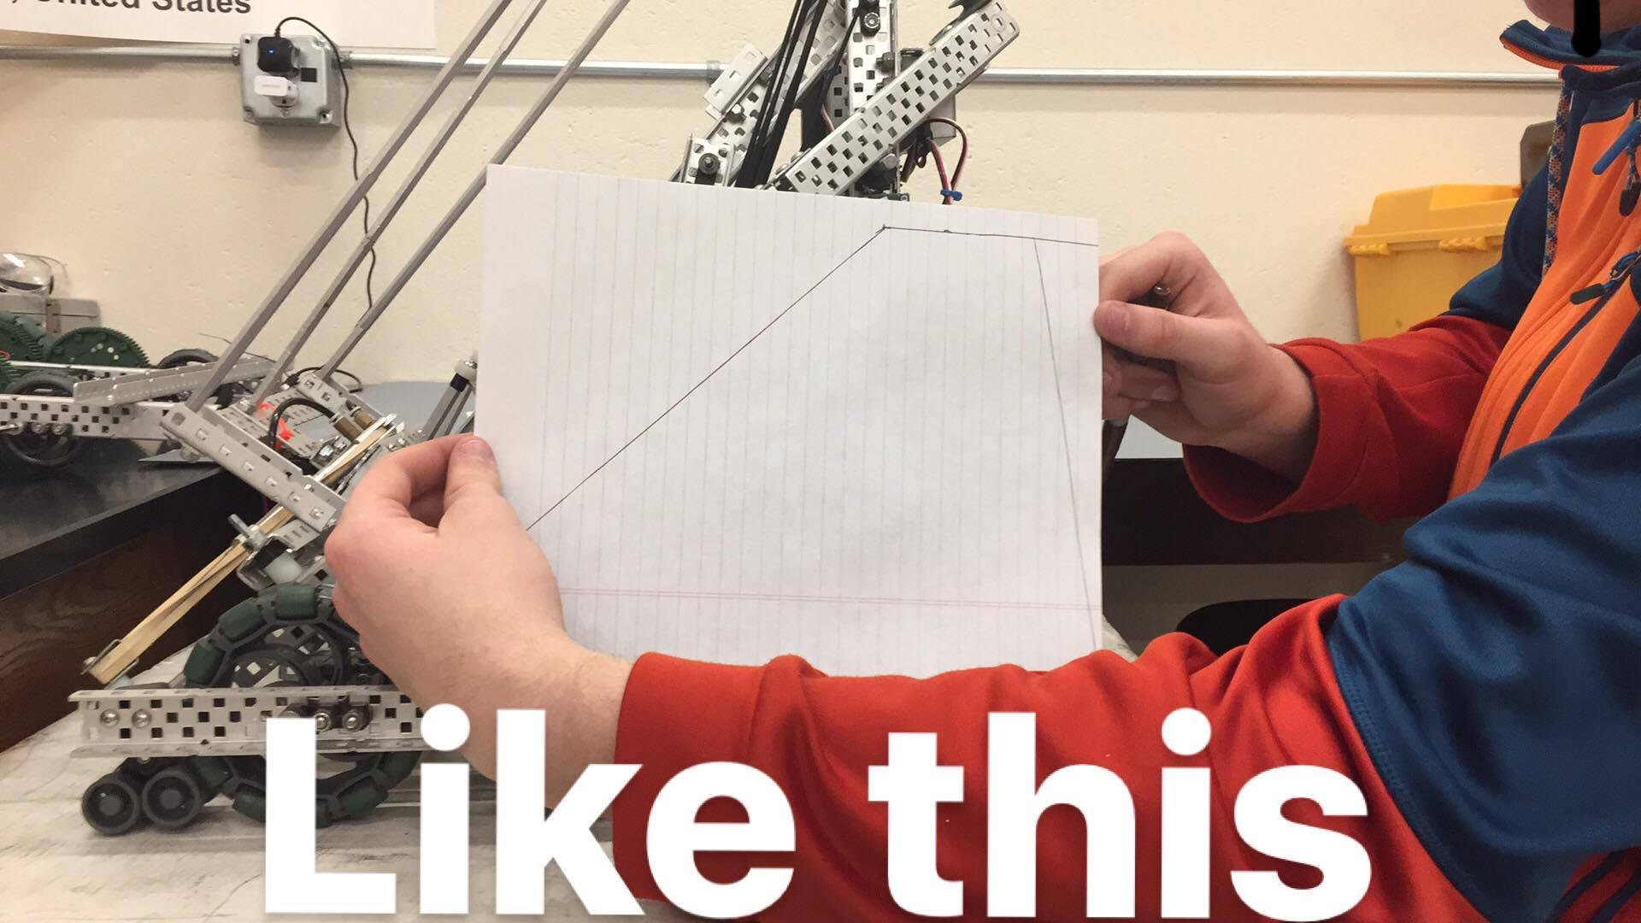

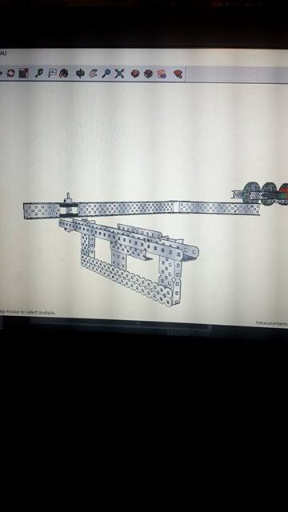

Goals For Next Time: Programming Autonomous / Driver Practice

Date: 2/27

Members Present: Kyle, Spencer, Noah, Max

Goals: Driver Practice

What was Done:

* Driver Practice with coaches
* William, while not here, wrote the mock-ups for the other three autonomous programs we want for the upcoming state competition

Goals for Next Time: Autonomous Programming and Driver Practice

Date: 2/28

Members Present: William, Kyle, Spencer, Noah, Max

Goals: Autonomous Programming

What Was Done:

* Using the mockups he made yesterday, William tested, and finished 3 of the 4 autonomous programs on the right side of the field. Each one does a specific thing for a specific situation.
  + Autonomous Program 1: While this was already finished, due to the rewiring, we had to slightly modify the program. This autonomous grabs the preload, as well as the star in the corner, then turns 130 degrees to grab the cube, and dumps all in one load. This is to be used when we want to get points, but do not want to contest in the middle scoring zone war that is bound to happen.
  + Autonomous Program 2: Drives and grabs the middle three stars that are by the wall, and the preload, drives back and dumps those four stars. This is to be used when our partner has a cube autonomous, and we want to maximize consistency.
  + Autonomous Program 3: Grabs the preload and the corner star, and dumps them. Simple and efficient. To be used when our partner has an elaborate autonomous, and we just use this to block and or to score a few more points.
* Driver Practice was also done

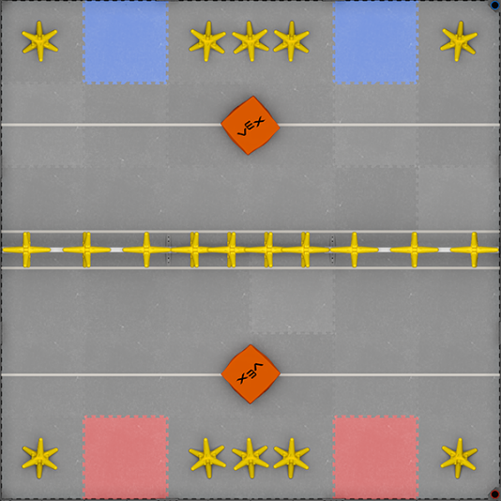

Goals For Next Time: Driving Practice and Autonomous

Date: 3/1

Members Present: Will, Kyle, Spencer, Noah, Max, Russell

Goals: Autonomous Programming, Driving Practice

What was done:

* Worked with the first three autonomous programs, and they now work on both sides of the field.
* For our fourth and last autonomous, we decided to make an autonomous that was a bit more complex, and therefore, this autonomous took a little longer to make overall.
* Autonomous Program 4: Quickly grabs the cube and preload and dumps them over the middle fence, then goes to grab the three stars, and then dumps those over the fence. Then it goes back to pick up any stars it may have missed. To be used when we are not worried about contesting the middle zone – because we know we will win – and want to win the autonomous period with sheer points.
  + While we did program this entire program, we want to test and fiddle with it a bit more, to make it slightly more consistent.
* Driver Practice was also done with coaches.



Date: 3/3

Members Present: William, Kyle, Spencer, Noah, Max, Caileen, Russell

Goals: Autonomous Programming, Driver Practice, Tournament Analysis

What Was Done:

* Worked with programming the 4th autonomous program to make it more consistent overall.
* Driver Practice

Tournament Analysis:

* In order to work to win this tournament, we need to work to have a faster offensive cycle time than our opponent. Clearly, we can split this goal into two separate categories: offensive, and defensive. Through following this strategy, we can win more games, and have a better shot at winning the tournament.
  + Offensive:
    - There are two main strategies we can employ offensively to increase our own offensive cycle time:
      * Scoring large amounts of stars in a consistent amount of time.
      * Scoring small amount of stars extremely quickly.
      * Generally, the first option will allow us to score more points in the same amount of time, however, from a net point perspective, ue to things we will discuss in the second category
  + Defensive:
    - There are three main strategies we can employ to decrease our opponents cycle time:
      * Throw stars in the path of the opposing robot, so they have to readjust.
      * Throw stars away from opposing robots, so they take more time to pick up stars.
      * Throw small amounts of stars, so they scatter, rather than dropping in a single group, so that it takes more time for opposing robots to pick them up.

Goals for the State Tournament: Win!

3/4/17

Members Present: All

Goals: Tournament Analysis

Analysis:

Drive Base:

Very Bad Bad Neutral Good Great

Explanation:

The drive caused us no issues throughout the day. While it was not the fastest drive at the competition, it suited our needs extremely well, and did not burn out on us, as it has in past tournaments. However, while we did not tip during this tournament, it is becoming increasingly clear that we will need to add some sort of anti-tip system.

Lift:

Very Bad Bad Neutral Good Great

Explanation:

The lift, beyond one incident that caused us to lose our first match, performed extremely well, and allowed us to consistently launch items into the far zone. Because of this, we were able to win the majority of our matches, and certainly had the potential to win the others.

Claw:

Very Bad Bad Neutral Good Great

Explanation:

We will rate this between neutral and good. While normally, we would have qualified this under the “great” category, it becomes lower by comparison. While we have rejected motor claws in the past, there were several versions of motor claws that performed admirably today. Due to their extended range of motion, they were able to more consistently pick up a larger amount of stars. While we still believe pneumatic claws are superior, we will have to look into the potential use of a motor claw.

Autonomous:

Very Bad Bad Neutral Good Great

Explanation:

For the first tournament, we actually had several different autonomous programs that functioned and worked consistently. We won the majority of our autonomous periods – even though one got set up wrong. However, our autonomous program, while consistent, could have done more, and/or worked to score more points, and/or could have been more productive through the use of PID. We will look into all of these options in the future.

Conclusion:

We had a large amount of success, however, we only were able to go 7-3 in qualification matches, due to some technical issues. We lost in the semi-finals. Luckily, due to our journal, we were able to win the design award, and therefore we qualified for worlds. Overall, we are happy with the results of this tournament, although we wish we would have been able to at least reach the finals of the state competition.

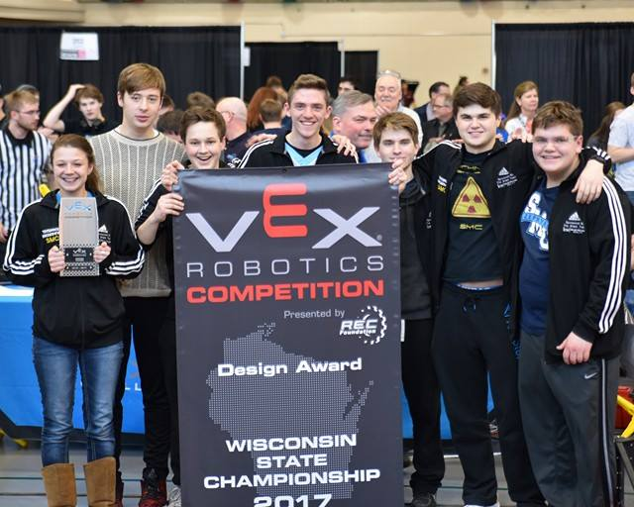

3/8/17

Members Present: Noah, Kyle, Spencer

Goals: Further Discussion

What Was Discussed:

* As a team, we decided to come up with a list of possible things we could do and/or test to make our overall robot better. We came up with the following:
  + Anti-tip system
  + Test Motor Claw System
  + Test 6-Bar System
  + Rebuild Robot
    - While this step may seem a bit contrived, we feel as though this could help us as we prepare for worlds. Considering the amount of rebuilds and fixes done, there are clearly some things within this robot that were just shoved on. If we can make minor improvements, and improve the overall build quality by rebuilding the overall robot, then we have an obligation to do so.
    - We started this step today, and built the chassis of our robot. We changed up the gearing system, still using chian, but using 60 tooth gears in order to have the robot be backdriven. This chassis was built within the attempt to minimize friction.
    - Furthermore, this chassis was built with speed in mind. While we do not have 6 motors, we have 4 turbo motors. This allows us to travel faster. While we would normally worry about burning out, the lessening of friction should help. We will test with more strenuous conditions when the robot is fully built.

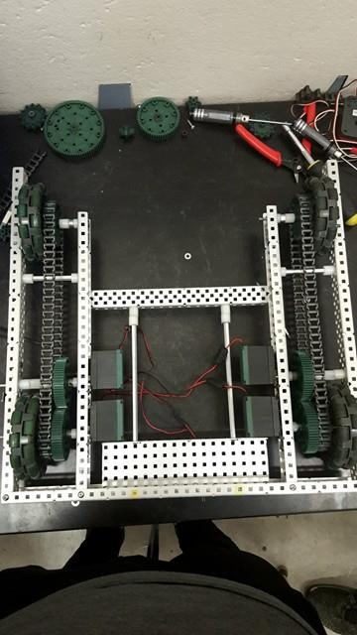

Goals: Keep Building the New Robot

3/9/17

Members Present: Spencer, Max, Kyle, Noah

Goals: Keep Building Robot

What Was Done:

* We decided to add encoders to the middle of the drive train, as we will add free spinning encoder modules similarly as we did on the previous robot.
* In the spirit on continued building of the new robot, we made two minor changes to the overall structure of the lift as we were rebuilding it:
  + We lowered the overall lift by two spaces in order to keep a lower profile, and making the overall powered arm even closer to the load – which enhances what the four-bar already is meant to do. However, this may be removed, as it creates problems while accessing the bottom two motors, which we will need to access for routine maintenance.
  + We made the structure between the bottom set of gears less intrusive. This should give us better access to the overall lift when maintenance is needed. However, this will also need to be tested, as we have no clue if extra structure is needed. If we need to add extra structure, we will – the integrity of the lift is more important than the ability to perform maintenance on the lift.

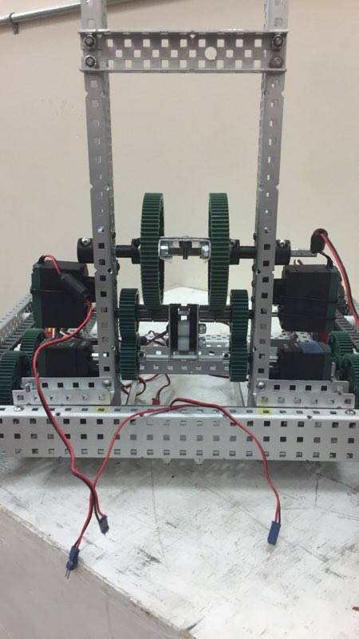 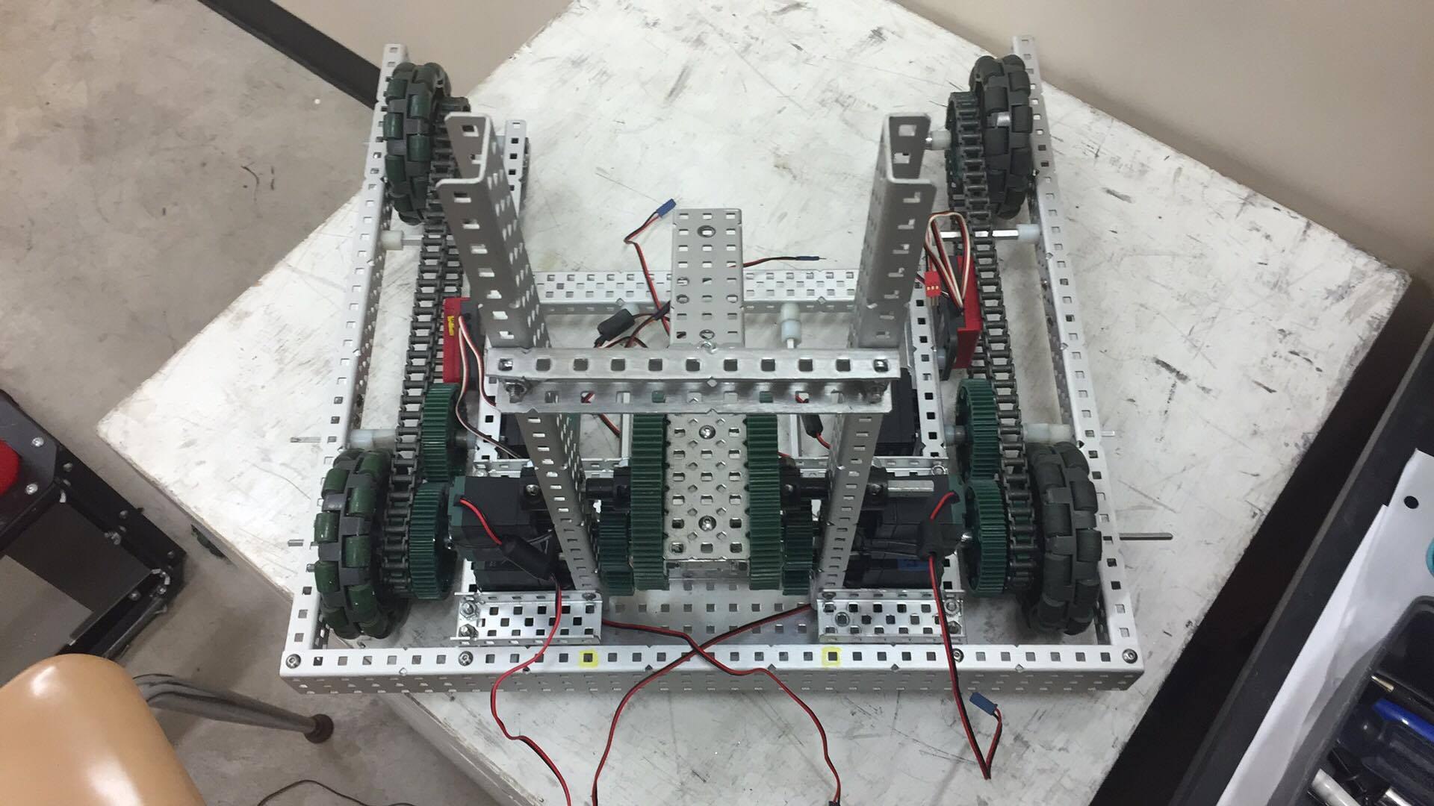

Goals for Next Time: Continue Rebuild

3/13/17

Members Present: Spencer, Max, Kyle, Noah

Goals: Rebuild Robot

What was done:

* Added Claw – No Modifications – Self Explanatory
* Completed Gearbox – No Explanation Needed – Added Same Elastics – No further modifications to gearbox
* Attached cortex to standoffs for ease of access – zip ties at the moment, but will create a more permanent and structurally sound solution in the future.

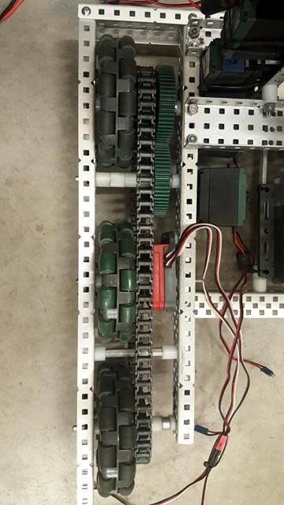 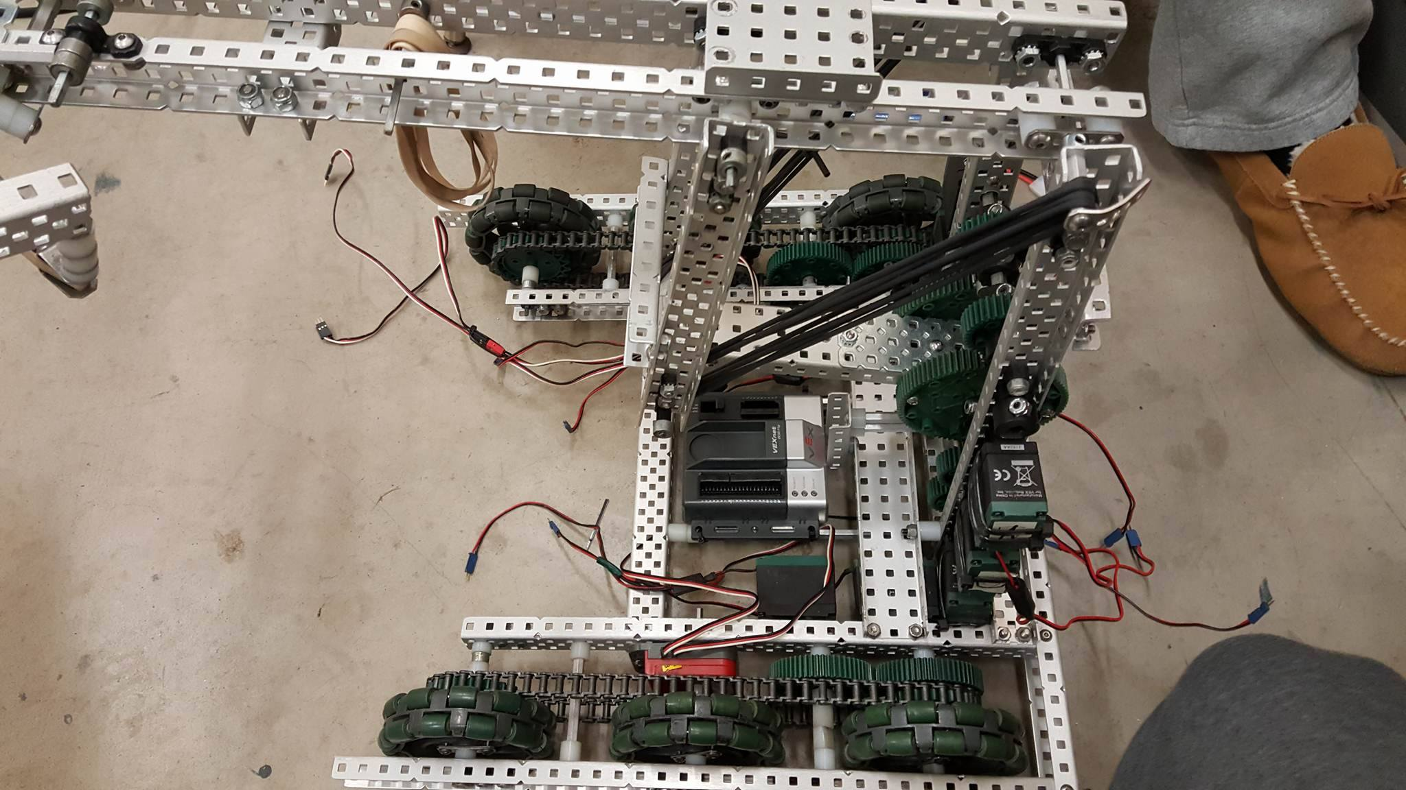

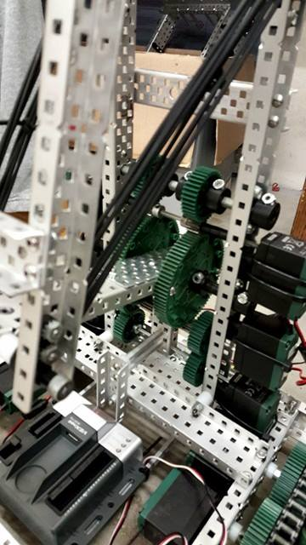

Goals For Next Time: Wiring

3/14/17

Members Present: William, Max, Spencer, Kyle

Goals: Work on Anti-tip

What was done:

* We considered the implementation of two separate anti-tip systems:
  + The first would use linear slides to propel a slide from under the robot, out onto the back of the robot.
  + The second would fling out from the top of the back of the robot, using legal vex springs in order to provide a sort of suspension.
    - We decided, in the future, we will implement the first system, as the second has a lesser amount of surface area, and thus will have a higher likelihood of failing within a match.

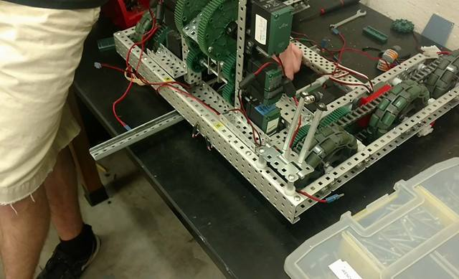

Goals for Next Time: Wiring

3/16/17

Members Present: Kyle, Spencer, William

Goals: Wiring, Driver Practice

What Was Done:

* We all worked to complete the wiring job today, so that Spencer could test out the individual systems, so we could see, what, if anything we needed to change in order to create an overall superior robot. Obviously, this took up the majority of the meeting.
* After finishing the wiring, we did a sort of “stress test” on the lift. While it seemed to handle fine with lower amounts of stars, when we lifted above 4 stars, the lift was obviously too slow. We may entertain the idea of putting our old gearbox back on, as we kept it intact.

Goals for Next Time: Fix Lift

3/18/17

Members Present: William, Noah, Kyle, Spencer

Goals: Fix Lift

What Was Done:

* Replaced Gearbox with the old one that we had on our state robot
* We did this because we saw how slowly this lift was performing under even normal situations, and we knew our previous lift performed better. More than likely, this was due to the lack of support down at the bottom of the overall lift system.

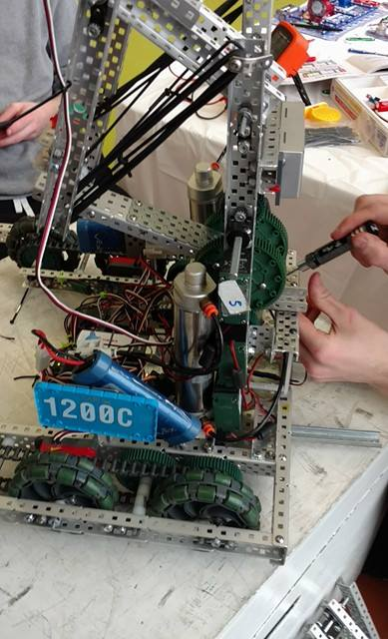

Goals For Next Time: Test Out Robot Systems

3/20/17

Who Was There: Noah, Spencer, Kyle

Goals: Wiring

What Was Done:

* Mainly, today was about wiring. As we said, when we wired before, it was more of a rush job. Therefore, we decided to spend today working to build a better wiring system so that we may be able to better perform maintenance in the future.
* We used the same color-code system as we have previously used in order to better understand what our wires do, and to be able to replace wires quicker.

Goals For Next Time: Driving Practice, Anti-Tip System

3/22/17

Members Present: Noah, Kyle, Spencer

Goals: Anti-tip System

What Was Done:

* We added and completed the first anti-tip system, as proposed on 3/14. We decided to put two linear slides near the center of the back of the robot for a few reasons: 1) having two allows us to have more support; 2) having them be more centric allows us to have more ability to turn in tight situations. However, instead of just using a linear slide system, we also created a release mechanism.
  + This release mechanism, as we have seen other robots throughout the year use with a large amount of success, was to attach axles to rubber bands, which in turn were attached to the bottom bar of the irregular four bar. These axles would be inserted into the linear slides in such a way that they could not deploy until the axle was removed – which would occur when the lift was raised.

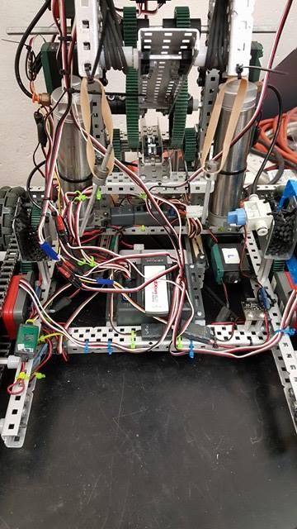

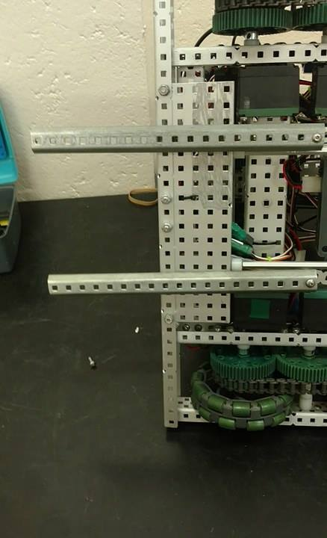

Goals For Next Time: Driving

3/26/17

Members Present: Spencer, Max, Kyle, Noah

Goals: Scrimmage!

* We invited several teams from the Wisconsin area to scrimmage with ourselves and 1200F this year. Overall, we were very happy with our robot’s performance, but these scrimmages only emphasize the fact that we need to overdo practice. We cannot practice enough. In a case where we are up against two other quality robots, there is not much we can do to guarantee the win, and thus, must rely on driver practice.

Next Time Goals: Practice / Organize

3/27/17

Members Present: William, Kyle, Noah

Goals: Organize

* Today was dedicated as a clean-up day, so we decided to work to organize our parts. Without the ability to quickly perform maintenance, we cannot hope to win matches, as we must be prepared for the worst. In the future, before the Worlds Robotics Competition, we will take other measures to ensure that we will be prepared for anything.
* (Insert Picture of Part Bins / Part Container)
* Today, we started discussing the possibility of building a secondary robot for two purposes.
  + Testing out the validity of the motor claws
  + Scrimmaging

Next Time Goals: Driver Practice

3/28/17

Members Present: Noah, Kyle, Will, Max, Spencer

Goals: Work on Secondary Bot

What was done:

* We wanted to make a bot to contrast the best overall aspects of our robot. So while we have a fast lift, geared for torque, and a bit of a slower drive, we decided to build this robot to have a quick drive, and an incredibly fast lift, geared for speed. We decided it would be best to use this, or a moderate approach. While we plan on using the robot we have built now, if we decide we like the new aspects of this new robot, we obviously will want to incorporate those aspects to their fullest extent.
  + To do this, we decided to counter our current 4 motor drive with a six motor turbo drive on this robot. We also decided to have a thinner drive, in order to have a shorter turn radius, allowing us to turn faster. While this sacrifices some structure, we decided to add wheels for structure on the outside – see pictures for details.
  + We added a 1 to 5 gear ratio, to counter our current robot’s 1 to 7, which is more torque orientated.
  + Noah and Spencer worked on this. Noah took the robot home, and built a similar four bar. We will continue working on this robot at the next meeting.
* The other thing worked on today was one issue that presented itself on our other robot. The bottom bar on the back of our robot, and everyone else worked to replace this bar. It was a fairly intensive job. We added a few more lock-nuts in order to improve the structure, so this doesn’t happen again.

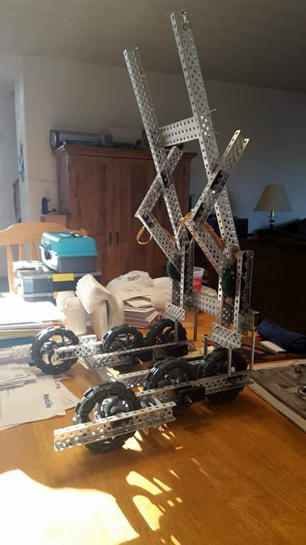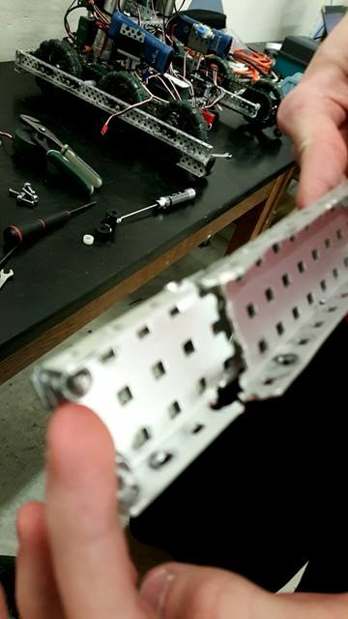

Goals For Next Time: Work on Second Robot

3/30

Members Present: Kyle, Max, Spencer

Goals: Work on Secondary Robot

* Put Motors on lift
  + We realized we had the option of running speed, torque, or turbo motors, however, we are running a 1 to 5 gear ratio, running any less than torque motors would burn out the drive.
* We drove around the secondary robot, and were shocked to see how quick it was at driving, especially turning. We attributed this to the close together and centralized wheels. The lift seemed to function, but without the weight of the claw, we can’t accurately measure its potential.
* On the current robot, the encoder wheels were offset. While this isn’t a large issue, it can bring up issues in programming when we want to use both encoders in order to calculate turn – having them offset screws up the turn radius, and we do not want that happening.
* Driving – In order to verify the integrity of the drive of the secondary robot – and to have fun with the super fast drive – we decided to drive the secondary robot on the field, and put it into a large amount of varying situations. Essentially, we were stress testing the robot.
  + Eventually, one of the front motors gave out. We had been testing it for awhile, but we still decided to upgrade the structure of the drive in the front in order to try to avoid it in the future. We should not have to ever have to deal with a burned out drive, as we have a 6 motor drive
* On the current robot, we have our anti-tip system connected with rubber bands. However, rubber bands stretch, causing us to take longer to lift the lift up. We want to be able to quickly establish our robot’s presence on the field, and if the antitip does not deploy quickly, we cannot do that.

Goal for next Time: Testing secondary robot

3/31

Members Present: Max, Spencer, Kyle

Goals: Maintenance, Robot Driving / Testing

What Was Done:

* Today, we decided to test out different drive setups for the secondary robot. In order to ensure that we will always have a drivable robot, we decided to try to use smaller omni-wheels. This, in practicality, increases the torque given to the drive, but reduces the speed, in the exact same way changing a gear ratio would.
  + While the small omni wheels allow us to control the drive to a much larger extent, we believe it releases too much speed for us to be competitive with that system, and worked to switch it back.
* We decided to test out the lift on our original robot with only four motors. While we run it with 6 at this current time, we have seen several robots run with four motor lifts, and if we can, we would like to do the same, so that we can have a six motor drive. While we need to do more testing, our driver said it felt almost the same with a cube and three stars, so we will continue to pursue this s an option.
* On the secondary robot, we built, and tested, a motorized claw.

Goals For Next Time: Continue working on Second Robot

4/2

Members Present: Noah, Will, Kyle, Spencer

Goals: Test both robots against each other

What Was Done:

* Today, both of our drivers, Noah and Spencer, worked to determine which bot they preferred. After careful deliberation, they decided to keep the original robot. While they both enjoyed the six motor drive, they would rather have consistency over speed. Speed is not useful when/if our drive burns out. Consistency is at the heart of this robot. On top of that, our drivers have been driving a pneumatic claw all year, so switching to a motor claw so close to worlds would not be the smartest move. For these reasons, we decided to use the original robot.

Goals For Next Time: Keep Working on the original robot

4/3

Members Present: Noah, Will, Kyle, Spencer, Max

Goals: Discussion

* We decided to rebuild the robot for two purposes – one, build quality, and to manage the wiring systems more efficiently. Secondly, we would like to anodize our robot – not for any particular building reason, but aesthetic can help, as marketing is an important part of alliance selection.
* To this end, we set up a new area in the back, complete with only the parts needed to build our robot. We found all the metal, elastics, screws, and sensors needed to build our current robot, and put them in the back room.
* Furthering this effort, we decided to paint the wheels. Kyle is working very hard to paint a set of six wheels white, to set with the black, white, and green aesthetic we have decided on.
* 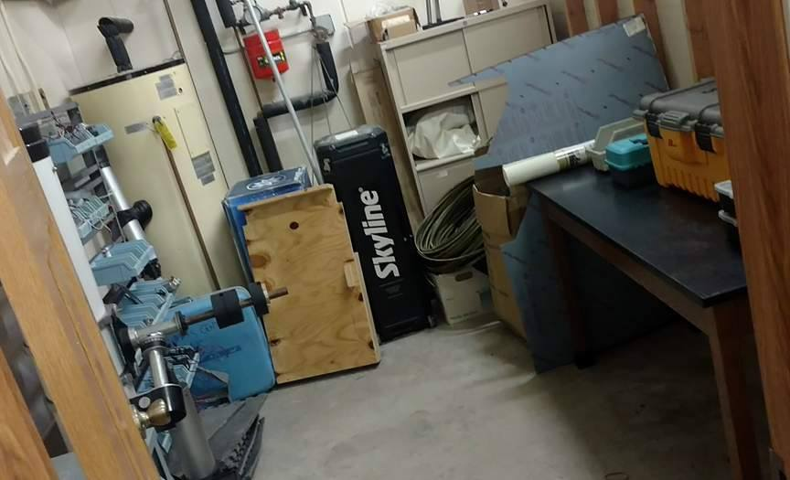 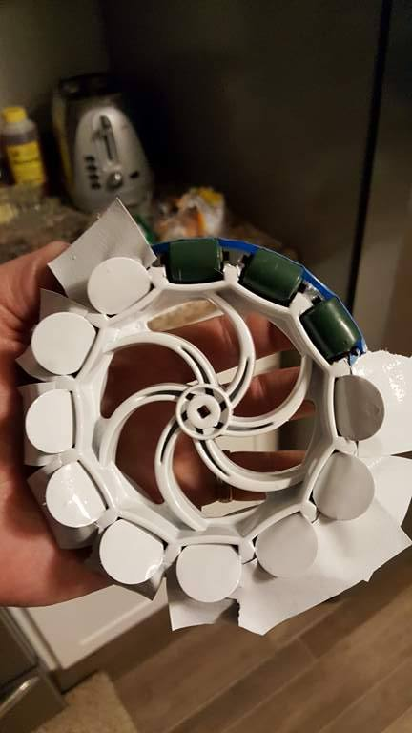

4/4

Members Present: Spencer, Max, Kyle

Goals: Lift/Drive Work

What Was Done:

* In order to get a faster drive on this robot, we moved two of the lift motors to the drive – and by this, we took two motors off the lift, and added two turbo motors to the drive. We tested out the robot afterwards for the rest of the night. The lift seemed to perform well, although it burned out once under a heavy load near the end of the night. We will have to do further testing to determine if we want to keep this orientation of the robot.

Goals for Next Time: Test Original Robot

4/6

Members Present: Spencer, Max, Kyle, Will, Noah

Goals; Build New Robot

* We received the anodized metal today, so we instantly started to work on the chassis system of our drive. This chassis was built exactly the same as our other chassis
* Secondly, as we were driving the original robot around, the lift burnt out again. Therefore, when the chassis was done, we attached non-anodized metal to the robot in order to test a lift system with a thinner gearbox. Since the gearbox is thinner, less power has to be distributed across the axle.
  + While the lift seems slow, it seems to carry a large amount of torque. We will need to do subsequent testing with this lift system.
  + We also made sure to add extra support to this lift, by using a piece of three wide to attach it to the front of the chassis.

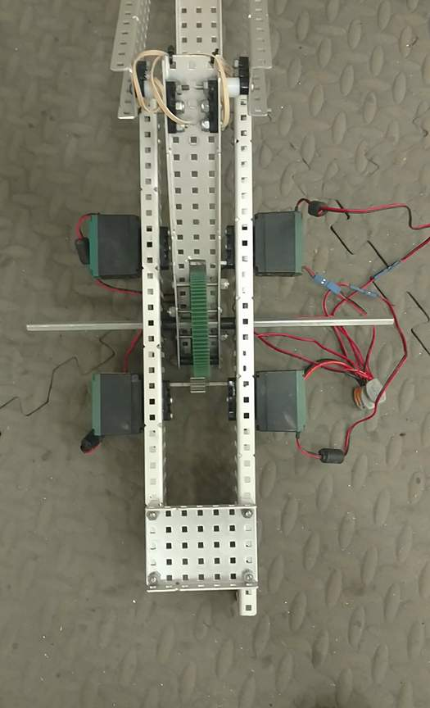

4/7/17

Members Present: Spencer, Max, Noah, Kyle

Goals: Testing

What Was Done:

* Subsequent testing on the lift system (for obvious reasons)
* Added the claw to the lift system, for obvious reason
* We still like the other gearbox better as of now. For now, this is a last resort.
* Because of this, we built our old gearbox, but made it a bit thinner, removing all necessary space within that gearbox, this should help it not to burn out in the future.

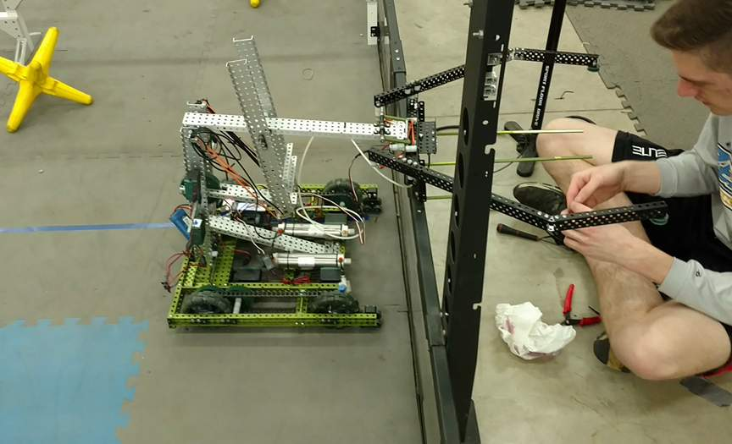

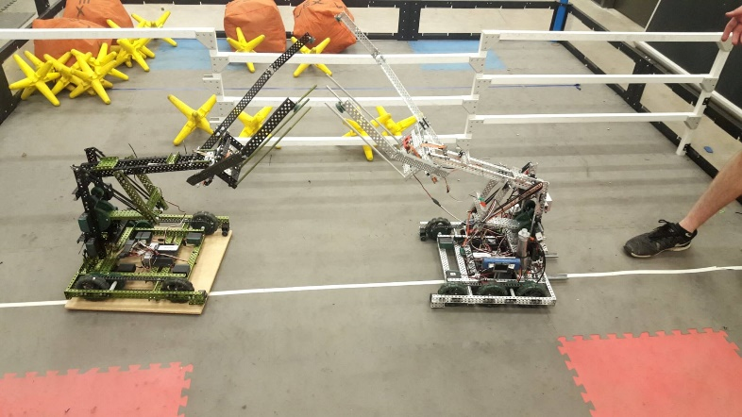

Future Goals: More Testing

4/8

Members Present: Spencer, Kyle, Max

Goals: Lift Work

What Was Done:

* Sadly, the burning out is still an issue, and because of this, we made the only decision we could have – put 6 motors on the lift – and put 4 on the drive. While this will make the drive slower, the lift will still work during competition.
* After that, we tested the lift. The lift functions extremely well, at least as well as our previous lift, and therefore, we will keep it for the time being.

4/9

Members Present: Will, Noah, Spencer

Goals: Autonomous Programming

What Was Done:

* Drive Testing: The drive system performed well, until we decided to try to push objects. A few minutes after we tried to do that, the drive burned out. The first measure we realized we could take was to remove the central encoder wheels. However, we would like to test other things before we take such drastic measures.
* Since we changed the configurations of several of the drive system, we have to reconfigure the PID systems we made a long time ago. These will help us during the autonomous period to stay accurate. If we can stay on course, even if an opposing team throws objects at us, we will gain a large advantage. We maintained the PID systems for:
  + Drive (Encoders)
    - Left and Right Side
  + Lift (Potentiometer)
  + Turning (Gyro)

Goals For Next Time:

4/11

Members Present: Will, Noah, Max, Kyle

Goals: Fix the Problem of the Drive Burning Out

What Was Done:

* In order to help the lift be able to carry a heavier load, Noah realized he could change the spacing of the four bar in order to add more torque to the lift.
* We considered several options to fix the problem of the drive burning out:
  + Moving the front back motor to the front (our drive is completely back driven now)
  + Change the sprockets
  + Remove the encoder wheels.
  + We did option one. However, after intensely driving the robot, it still burned out the drive. After realizing option two was not feasible, we removed the encoder wheels. However, we kept option one completed, as redistributing the motors definitely helped the drive

4/12 – 4/13

Drive Practice / Auton Work (See Auton Journal)